DATE OF NOTICE

Road Closure Notification – Change of Access
Access means the way you can walk, ride or drive to or from a place.
Address of Works: | e.g. Footpath outside 333 Bridge Road Richmond
How will access change: | e.g. The road will be closed during the day while we complete our works and will re-open at the end of the day.
Dates of Works: | Start Date to End Date
Times of Works: | Start Time to End Time
Contingency Dates:  Or  Monthly Notification Letter Option | Should works be unable to proceed on any of the above dates, the works will be completed on the following dates:  Start Date to End Date  As the dates mentioned above may require unforeseen changes, we will distribute a courtesy letter 2 days prior to each out of hours work date to ensure you are kept informed.
Approved Works: | e.g. Concrete Pour, Tower Crane Erection/Removal
Council Application Number: | xxxx

Things you should know about our works and how they may impact you:

 | Pedestrian arrangements (include how pedestrians will access the area if safe to do so)
 | Bicycle arrangements (remove if not applicable)
 | Vehicle Access (include how vehicles will access the area)
 | Parking arrangements (must include if parking will be reduced and if residents can continue to park their cars in the area or need to make alternative arrangements)
 | Property access arrangements (must include if access will be maintained and how)
 | Expected truck or heavy vehicle activity – (remove if not applicable)

Works Location

Dates of works | Times of works
Start Date to End Date | Start Date to End Date

We will do works here: Access will change here:

(Select the map below and paste your map in its place. Arrows and boxes are movable.)
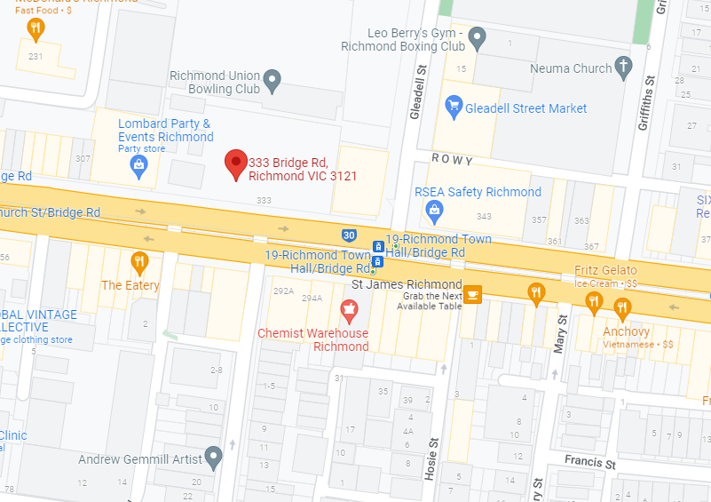

Contact Details

 |  | Name from Company  04XX XXX XXX  email@company
City of Yarra Contact
9205 5555
info@yarracity.vic.gov.au

