March 24, 2020
Project Number: 1000515
Ross Hardie
Alluvium Consulting

Dear Ross
RE: Yarra Bend: River Front Area Groundwater Review
Scope
This letter provides a summary of CDM Smith’s review of the Douglas Partners Report on Geotechnical Investigations and Groundwater Study Yarra Bend: Riverfront Area Heidelberg Road, Alphington, 2020, prepared for Alphington Developments Pty Ltd (The Report).
CDM Smith understands from a meeting held at Yarra City Offices (27th February 2020) that there exist several hypotheses for the driving cause of the river bank slumping, that have implications to long term mitigation options aimed at stabilising the bank and preventing further slippage.
These hypotheses include:
- Site works (i.e. water pondage and earth works) have increased water infiltration, groundwater recharge and groundwater flow towards the river, creating an increase in river bank soil moisture.
- A reduction in drainage of groundwater away from the river bank due to the decommissioning of the North Yarra Sewer Main, eastern section within the site.
The scope of this review is to consider if sufficient information is provided in the report to have confidence that the underlying causes in relation to groundwater processes of the localised slumping at the river bank are understood, such that any proposed mitigation approaches will be affective.

Summary of Douglas Partners findings
The report provides an assessment of the likely contributing factors to the cause of the slumping. Of which the key drivers are:
- The near vertical, 2.5 m to 3 m high river edge banks, with a relatively flat terrace extending behind the bank to the toe of the adjacent embankment, and
- Moisture increases or saturation of bank materials from off-stream sources. However, the report then concludes that upgradient groundwater conditions are inconclusive in demonstrating that recent upgradient conditions have caused the recent groundwater level increases.

In addition, the report provides a brief narrative around ‘Up Gradient” influences, concluding that there is a hydraulic connection between the Basalt Aquifer of the terrace setting and the alluvial sediments of the terrace. Groundwater gradients west of Latrobe Avenue were concluded not to be a contributing factor, while groundwater gradients east of Latrobe Avenue are probably a contributing factor.
The mitigation measure proposed in The Report is the installation of temporary sub-soil drains along the eastern side (from Latrobe Avenue) of the river bank.

Groundwater levels Review
The report as it stands provides qualitative assessments of different possible causes of the slumping, however does not provide any quantitative assessment or analytical solutions to support The Report’s conclusions. It is recognised that the intermittent record of groundwater levels and the decommissioning of bores installed pre-2015 makes interpreting the drive of changes to groundwater levels over time problematic.
However, some initial observations from the data can be made and are outlined below.
Figure 1 represents the available bore data up until 2015, corresponding to the timing of the decommissioning of the Sewer drain. What is evident is, with exception of bore MW4, located at the Rivers edge (Figure 2), all bores show a rise in groundwater levels from 2014 to 2015, during the time sewer decommissioning took place (It is important to note that CDM Smith understands that only the eastern section of the sewer was decommissioned in 2015, the western section had already been decommissioned). An interesting observation of this data is that bore MW3 and GW8 are located adjacent to the section of the sewer main that was already decommissioned. This suggests that an increase in recharge has occurred across the site, as opposed to a very localised process effecting only a portion of the site.
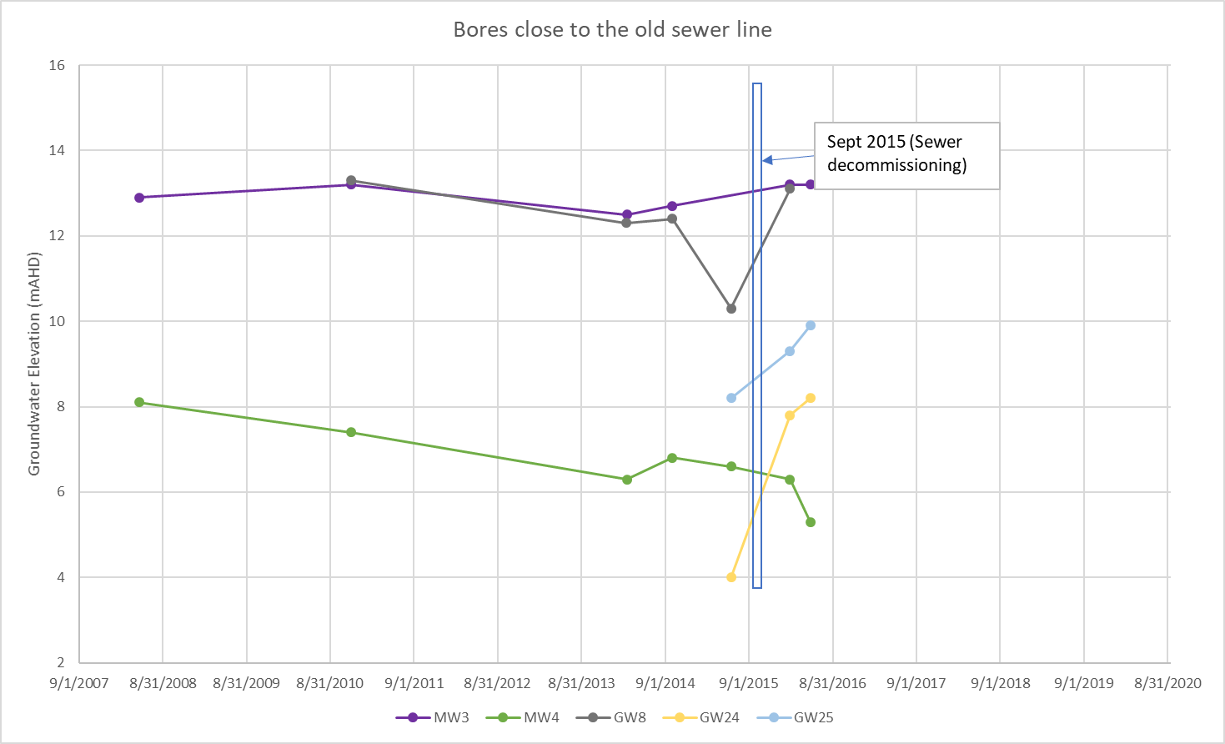
Figure 1. Bore hydrographs associated with sewer main decommissioning

Douglass Partners provided several north to south cross sections illustrating the location of groundwater bores, lithology and recent groundwater levels. The cross sections support their conclusion that the existing groundwater levels across the eastern section of the site are elevated with respect to the river’s edge and location of slumps and are therefore, probably contributing to the development of, and ongoing instability of, the river bank slumps. Figure 3 illustrates one of the sections from Douglas Partners, that is aligned with the eastern area of river bank collapse. Several mark-ups have been included showing the location and depth of the decommissioned sewer and historical groundwater levels. What is apparent is that existing and historical groundwater levels are slightly elevated compared to the sewer main, indicating a groundwater gradient higher than the sewer elevation existed. Current groundwater elevation in DG7 (10 m AHD) is around 5 metres higher than the sewer main, and when compared to 2016 level in GW24 (8.2 m AHD) suggest groundwater levels may still be rising. Unfortunately, no current groundwater level measurements exist at the location of GW 24, to determine if;
- A groundwater mound has occurred at DG7, with a higher elevation than GW24, such there is a local source of recharge, or
- Groundwater levels at GW24 have also rising, indicating the more regional groundwater is general increasing in level, and that the regional groundwater gradient is still north to south towards the River.
Irrespective of the cause of the elevated groundwater levels (i.e. a driving head) with respect to the river terrace, groundwater will continue to flow towards the river edge, contributing to an increase in soil moisture, increase in risk of further slumps, as concluded by Douglas Partners.
What remains un clear is what is causing the elevated groundwater levels, several questions exist.
- If the pre-decommissioning (of the sewer) state was that the groundwater flow from the north to the River was drawdown and intercepted by the sewer main, preventing a hydraulic gradient to the Rivers edge to occur, it is unlikely that the decommissioning of the sewer and subsequent reduction in sub surface drainage away from the site could cause groundwater levels site wide to rise 5 metres above the sewer depth. Additional modelling is required to determine of this rise on groundwater levels could be caused by blocking a sub-surface drain.
- Bore GW24, had a 4.2 metre increase in groundwater levels from 2015 to 2016. While this period does coincide with the decommissioning of the sewer main, it is difficult to conceptualise how that process could cause such a large increase in groundwater levels (i.e. groundwater coming from storage under the site or throughflow as opposed to recharge).
- The potential of the development localised elevated groundwater levels suggests a point source of recharge. If the process was driven by regional flow (north to south), then it would be expected that a gradient exists from bores GW24 to DG7, additional data is required to determine of this is the case.

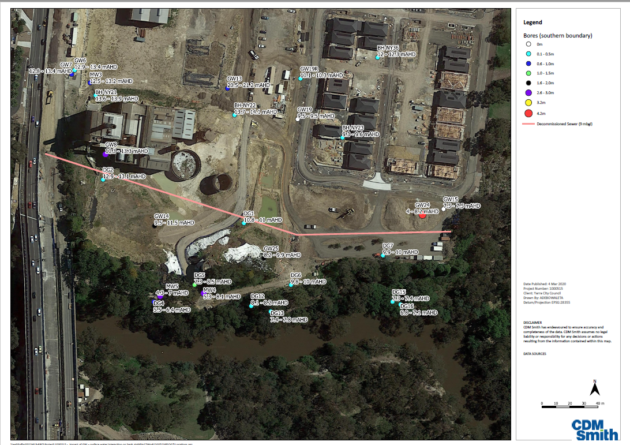
Figure 2. Location of groundwater bores and location of sewer main. Blue line shows approximate location of section in Figure 3.

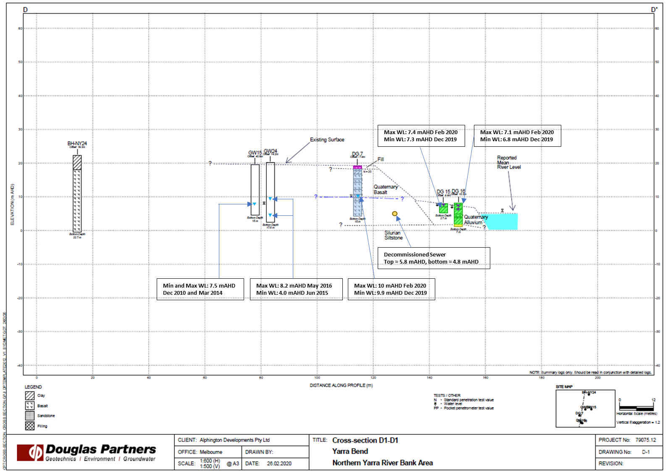

Figure 3. North South section showing groundwater levels and approximate location of the sewer main.

Figure 4 represents two west to east cross sections that run approximately on top of the line of the sewer main (Figure 2), illustrating the elevation of groundwater levels in relation to depth of the sewer. The length of the decommissioned sewer main in 2015, runs approximately from 210mts to 350mts (indicated by blue arrow). This section illustrates that groundwater levels are predominately higher than the sewer, irrespective if they occur adjacent to the recently decommissioned section of the sewer or the western section of the sewer, which was decommissioned earlier.

Concluding Remarks
Douglas Partners report provides a factual description of the data that exist across the site. The report provides qualitative assessment of the probable causes of the slumps.
At this stage, it is still not possible to confirm the underlying cause of the elevated groundwater levels, and as such, how effective the short-term mitigation of sub soil drains may be and for how long increased groundwater flow to the river bank will continue.
It is unlikely that ongoing monitoring of groundwater bores alone will be able to provide adequate information to assess the effectiveness of the mitigation plan and/or to determine the cause of the elevated groundwater levels and how long they may persist for, creating ongoing risk of river bank collapse.
A more detailed assessment is required to understand groundwater flow dynamics, including:
- Calculation of groundwater flux to the river bank slumps in order to assess how long groundwater discharge may persist for.
- Groundwater recharge and mounding calculation to determine the relative influence of the decommissioned sewer and site sourced recharge to the development of the elevated groundwater levels. This may require the installation of a new groundwater bore up gradient of the slump areas, to observe current regional groundwater flow gradients.
- Modelling of how effective draining of the subsurface will be in reducing soil moisture and drawing down the groundwater mound.
- Water quality measurements of the groundwater and seepage (within the slumps) to determine the likely source water.

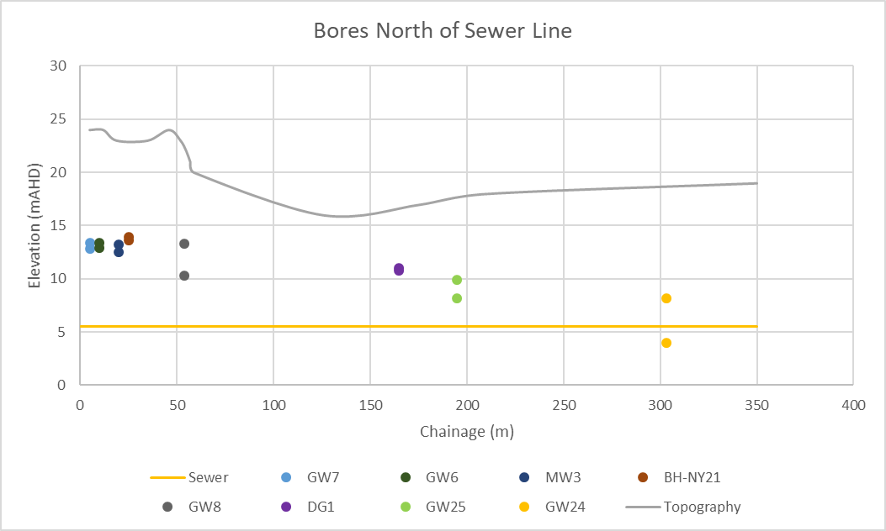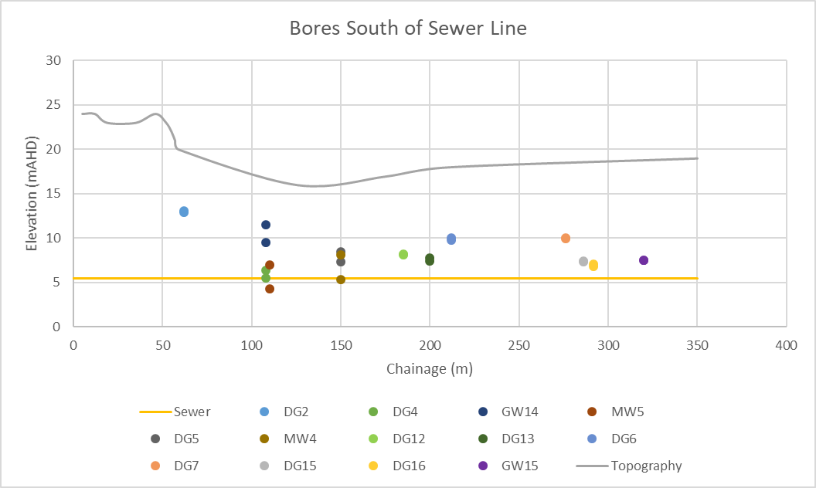

Figure 4. Groundwater levels relative to the depth of the sewer main (blue arrow indicates length of sewer line decommissioned in 2015). The offset distance of each bore to the sewer line is shown in Figure 2.

Sincerely

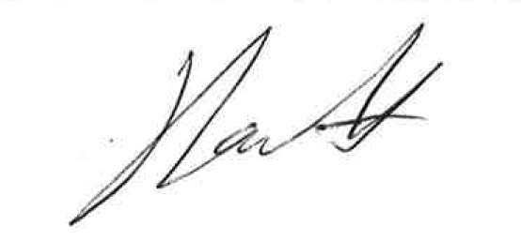
Dr Jon Fawcett  Associate Hydrogeologist | Francis Dean  Senior Hydrogeologist

