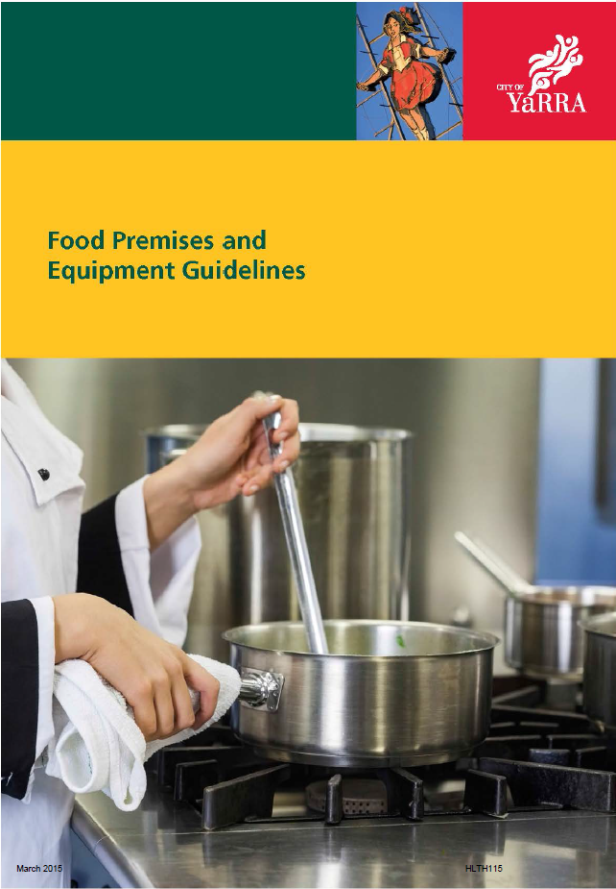

Contents

Page

Contents 3

Introduction 5
1. General Design and Construction of Food Premises 6
Appropriateness of Premises 6
Adequate Space 6

Ability to Keep Premises Clean 6
Exclusion of Dust, fumes, Smoke and Other Contaminants 6
Pest Control 7
Alfresco/Outside Dining 7
Water Supply 7
Sewage and Waste Water 7
Storage of Garbage and Recyclable Waste 8
Ventilation/Mechanical Exhaust Systems 9
Lighting 9
2. Floors, Walls and Ceilings 10
Floors 10
Walls and ceilings 10
3. Fixtures, Fittings and Equipment 11
Adequacy of Fittings Fixtures and Equipment 11
Design, Construction and Location of Fixtures, Fittings and Equipment 13
Hand Washing Facilities 14
4. Other Requirements 15
Storage of Chemicals, Clothing and Other Items 15
Toilet Facilities 15
Food Transport Vehicles 16
Appendix – Registration and Registration Inspection Checklist 17

Introduction
These guidelines give advice on the construction and fitting out of food premises. It will be of assistance for new premises or premises undergoing renovations or improvements.
All food businesses must comply with the requirements of Standard 3.2.2 of the Food Standards Code - Food Safety Practices and General Requirements. These standards set out the required hygiene outcomes that must be achieved, regardless of the type of premises that is used. Food businesses will find it easier to comply with this standard if the food premises is suitably constructed and equipped. Standard 3.2.3 of the Food Standards Code - Food Premises and Equipment sets out the legal requirements for food premises, fixtures, fittings and equipment and food transport vehicles. These guidelines give advice on complying with Standard 3.2.3.
There is no list of specifications that could apply to the design and construction of food premises that will provide the “ideal” premises to meet the food safety outcomes that must be achieved. Food handling activities vary from food business to food business and the requirements for adequate and appropriate fixtures, fittings and equipment for food premises used by those businesses will differ. It is important that the setting up of any food premises takes into account the nature of the food handling activities, the food safety outcomes that must be complied with and any possible future changes to the operation of the food business. Complying with the outcomes of the food safety standards is always the main priority.
There is greater opportunity to design, construct and fit out new premises with as many features as possible that will enable the premises and equipment to be easily and effectively cleaned and to facilitate food safety practices. There are also cost advantages in doing this at the time of construction.
For specific details of the legal requirements reference should be made to the Australia New Zealand Food Standards Code - Standards 3.2.2 Food Safety Practices and General Requirements and Standard 3.2.3 Food Premises and Equipment. A copy of these standards can be obtained from the Council’s Health Protection Unit.
The relevant Clause of Standard 3.2.3 is provided next to the main headings in this document for reference purposes.

1. GENERAL DESIGN AND CONSTRUCTION OF FOOD PREMISES
1.1 Appropriateness of Premises (Clause 3(a))
Any food premises must be appropriate for its intended use. Materials used to construct the premises must be appropriate for food handling activities occurring within the premises. They must be durable under the conditions they are being used, not require frequent or temporary repairs and not be made of materials that may contaminate food.
Construction and workmanship must be to a high standard in food preparation areas. For example, rough grouting between tiles, tiles laid unevenly or roughly finished render on walls would not comply with the standards.
1.2 Adequate Space (Clause 3(b))
The food premises must have adequate space to carry out all activities. It is difficult to determine space requirements at the design stage but the following factors should be considered:
- Separation of raw materials and finished product.
- Storage space, including that needed for recalled products.
- Numbers and types of equipment to be installed.
- Staff numbers.
- Whether there are food displays.
- Cleaning methods and types and sizes of equipment to be cleaned.
- Quantity and type of garbage storage.

1.3 Ability to Keep Premises Clean and Sanitary (Clause 3(c))
Premises and equipment that are designed and constructed so they are easy to clean are more likely to be kept clean. When designing premises the ability to keep all areas of the premises clean must be kept in mind. The following are some considerations:
- Architraves and skirting boards should be avoided as they provide an area for dirt and dust to collect.
- Service pipes should be concealed in floors, walls or ceilings or fixed off these surfaces at least 25 mm to allow cleaning.
- “Boxed in” areas (such as under cupboards) that cannot be completely sealed should be opened up or provided with access for inspection and cleaning.
- Equipment such as cooking appliances must be installed so that all areas around the appliances are accessible for inspection and cleaning (see 3.2).
1.4 Exclusion of Dust, Fumes, Smoke and Other Contaminants (Clause 3(d))
Dust, dirt, fumes and other contaminants must be excluded from the premises because they can contaminate food and food contact surfaces and taint food.
- If dust and dirt are likely to be blown through doorways and windows they must be capable of being closed which will also help keep pests out.
- Air intakes for ventilation systems must be located where they will not draw in contaminated air.
- Toilet areas, laundries and living areas must be separated from food handling and storage areas by airlocks or self-closing doors.

1.5 Pest Control (Clause 3(d))

Animals and pests can be a serious source of contamination, so the premises must be proofed against their entry and harbourage. Effective measures include:
- Installing flyscreens, heavy-duty fly strips or self-closing doors to doorways.
- Installing mesh screens on windows and vent openings.
- Fitting weather strips to the base of doors.
NOTE: If there is no likelihood of pests getting into the premises, such as in shopping centres, then the above measures are not generally needed.
- Sealing gaps around pipes that pass through walls.
- Sealing all gaps and cracks in the premises where insects may live or hide.

1.6 Alfresco Dining (Outside) (Clause 3)

Premises that have open shop fronts, windows or doors and outside dining areas must still achieve the requirements of 1.4 and 1.5 in regard to excluding dust, fumes, smoke, other contaminants and pests.
These premises will need to take additional precautions to protect food and surfaces from contamination such as:
- Fitting sliding doors to bain-maries, cold food displays and other similar food display units.
- Locating food preparation, storage and serving areas away from open areas or behind effective barriers and screens.
- Having positive air pressure inside the premises or having air curtains above open doorways and windows.

1.7 Water Supply (Clause 4)
The premises must have an adequate supply of clean water. When hot water is used in any operations there must be an effective and adequate hot water service to meet all the needs of the premises.
Hot water services need to be located close to hand washing facilities so that it does not take too long for the warm water to be provided.

1.8 Sewage and Waste Water Disposal (Clause 5)

1.8.1 General Sewage and Waste Water Requirements

All sewage and wastewater generated by the premises must go to the sewerage system to prevent contamination of food, premises or the water supply. The sewerage system must comply with all plumbing regulations and requirements.
There must be no leakage or discharge of sewage or waste water, e.g. dirty mop water, to the stormwater system. Food businesses must be aware of the location of the stormwater drains around the premises to ensure they are not used to dispose of sewage or waste water. It is a good idea to mark them as “Stormwater Only”.

1.8.2 Grease Interceptor Traps
The requirements for grease interceptor traps (GITs) are set out in the relevant water authority’s Schedule for Minor Trade Waste and Schedule for Major Trade Waste. Contact the relevant water authority for further information. Within the City of Yarra this will be either City West Water or Yarra Valley Water.
Grease traps should not be located within food preparation and storage areas and should preferably be outside the building. Locating grease traps inside the premises can result in contamination problems, especially when the grease taps are emptied.
1.8.3 Trade Waste Agreements
All food premises are required by the relevant water authority to have a trade waste agreement.

1.9 Storage of Garbage and Recyclable Waste (Clause 6)
1.9.1 General Requirements
Premises must have facilities for the storage and disposal of garbage and recyclable waste that:
- adequately contains the volume and type of garbage and recyclable waste.  - keeps pests and animals away from it.  - are designed and constructed so that they can be easily and effectively cleaned. | 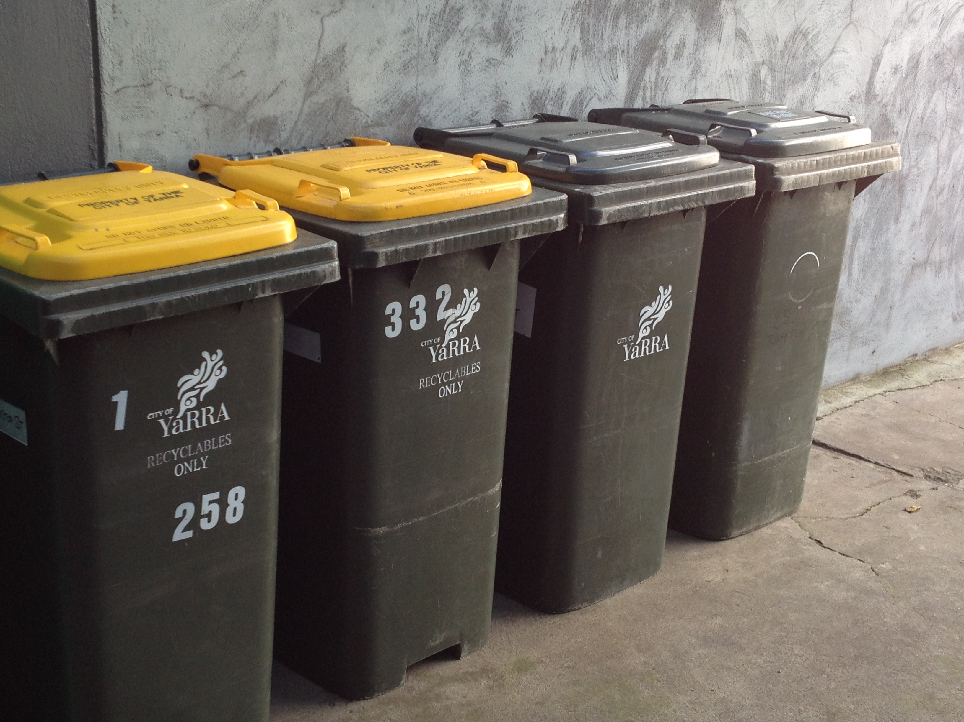
1.9.2 Garbage Storage and Bin Wash Areas
It is recommended that a bin storage and wash area be installed.
This area should be:
- Paved and large enough to store the number and type of bins needed by the food business.
- Graded and drained to a silt trap connected to the sewer as required by the water authorities.
- Provided with a border or barrier (bunded) to prevent the escape of wastewater.
- Provided with a supply of water (preferably warm) for washing bins.
The garbage storage and bin wash area should be located outside. If there is no room outside, the area can be located inside provided it is separated from any food handling and storage areas. If it not possible to provide a bin storage and wash area the business must make alternative arrangements for the cleaning of bins.
Note: Disposing or allowing garbage, wastewater or recyclable waste to pollute the environment including the stormwater drains is a littering offence under the Environment Protection Act 1970 (EP Act). Providing an appropriate bin storage and wash area should ensure that the premises does not contravene these requirements of the EP Act.
Rubbish bins must be able to be stored within the property boundary. Council’s Local Law No 3 does not permit rubbish bins to be stored on Council land or roadways (including laneways and footpaths) unless it is out for collection.

1.10 Ventilation (Clause 7)
1.10.1 General Ventilation Requirements
The premises must have sufficient natural or mechanical ventilation to effectively remove fumes, smoke, steam and vapours from the premises to minimise the likelihood of airborne contamination of food.
1.10.2 Mechanical Exhaust Systems (MESs)
MESs that comply with Australian Standard 1668 should be installed above cooking equipment such as deep fryers, hot plates, frying pans, ovens, donut machines, and commercial dish washing machines. Limited numbers of smaller appliances may not require MESs above them if they only discharge a small amount of grease or steam and the surrounding areas can be easily cleaned.
MESs are equipment and must meet the general requirements for fittings, fixtures and equipment detailed in Section 3.2.
MESs above cooking equipment must have removable grease filters, condensate gutter and drain plugs. Generally they should have a capture velocity of 0.5m/s uniformly across the face of the hood to ensure fumes, smoke and other vapours are effectively removed.
Cooking equipment must be positioned beneath and within the perimeter of the MES so it can capture all fumes, smoke, steam, vapours and odours.
Where the cooking appliances generate heat or steam only, grease filters are not necessary.
Yarra Building Services can provide further information on Australian Standard 1668 and can be contacted 9205 5356.

1.10.3 Location of Flues and Vents
The inappropriate location of flues and vents may result in odour or noise problems and may create a nuisance to adjoining premises. Such nuisances may be an offence under the Public Health and Wellbeing Act 2008. Flues and vents should be located where they will not affect adjoining premises.

1.11 Lighting (Clause 8)
Food premises must have sufficient natural or artificial light to see if all areas of the premises and equipment are clean and to find any signs of pests such as mouse droppings.
Light fittings should provide at least 500 lux in food preparation areas, at least 300 lux in wash up, storage and toilet areas and at least 150 lux in food and equipment storage areas.
Low levels of light are acceptable in dining and customer areas but sufficient additional supplementary light must be able to be provided for inspection and cleaning purposes.

Light fittings are equipment and must meet the general requirements for fittings, fixtures and equipment (see Section 3). It is recommended that they are flush mounted or recessed into the ceiling and that light globes are encased in unbreakable covers to reduce a contamination hazard should they break.

2. FLOORS, WALLS & CEILINGS

2.1 Floors (Clause 10)
Floors in food handling, food storage and wash up and staff areas must be impervious, able to be thoroughly cleaned, laid so that there is no “pooling” of water and unable to provide harbourage for pests.
Floor surfaces also need to be able to withstand the type of cleaning procedures (including chemicals) to be used and the amount of wear and tear occurring during food handling operation such as moving of heavy equipment or as a result of the amount of foot traffic.
Suitable materials would be floor tiles (with flush water resistant grouting), commercial quality sheet vinyl or concrete that has been treated to make it water and moisture proof.
2.1.1 Floor drains
Floor drains should be installed where large amounts of water will be used to clean the floor. Where floor drains are installed the floor must be graded and drained to the floor drain.
2.1.2 Coving of Floor and Wall Joins
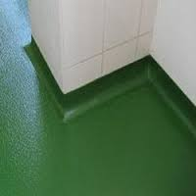 | Coving of the floor and wall joins in food preparation and storage areas allows these areas to be more easily cleaned. It can also help with cleaning of “difficult to reach” areas such as under cooking equipment and preparation benches. To achieve a suitable “coved” finish there needs to be a smooth transition from the floor to the walls so that the angle between the floor and wall (or fitting) is rounded off. If floor tiles are used special curved tiles are usually available.
“Stick on” curved material applied over the top of the floor and wall join is not recommended as it is difficult to ensure that it sticks strongly enough to the surfaces and is likely to create ridges and ledges that can trap dirt and grease.

2.2 Walls and Ceilings (Clause 11)
Walls and ceilings must be impervious, able to be easily and effectively cleaned and unable to provide harbourage for pests.
Walls above and behind cooking equipment, food preparation benches, wet areas and other areas that may come into contact with food or the areas where the wall requires frequent cleaning should be lined with a durable materials such as ceramic tiles, vinyl sheeting or stainless steel to a height of about 1.8 metres above the floor or 0.45 metres behind benches. The material used on the walls must be stuck securely on the wall so that there are no gaps that could hide pests such as cockroaches.
As previously mentioned architraves, skirting boards, picture rails or any other projections on walls and ceilings should also be avoided to prevent areas where dust and grease can build up. Service pipes on walls and ceilings should be concealed in the wall or ceiling or fixed off the wall or ceiling at least 25mm.
Generally it is suitable for walls in other areas and ceilings to be painted with a washable paint, preferably, light in colour.
Ceilings above food preparation and storage areas should be smooth sealed plaster. Painted plasterboard ceilings are adequate. “Drop in” panels may provide access to insects, pests and dust unless they are effectively sealed down. As they are difficult to seal properly they are best avoided. Rough ceilings and acoustic tiles are not suitable above food preparation and storage areas as they are difficult to clean

3. FIXTURES, FITTINGS & EQUIPMENT

3.1 Adequacy of Fixtures, Fittings and Equipment (Clause 12 (1))
Premises must be adequately equipped to receive, store, process, package and sell safe and suitable food, keep the premises clean and free of pests and staff can comply with requirements for personal hygiene. The type of equipment required depends on the operation of the premises but the following items need consideration.

3.1.1 Cooking/Heating Equipment
If food is to be cooked or processed the premises must have adequate equipment to ensure that the cooking process reaches the temperature required to destroy pathogens that may be present in the food.

3.1.2 Food Storage
The premises must have adequate storage facilities that protect food from contamination and keep potentially hazardous food under temperature control during storage.
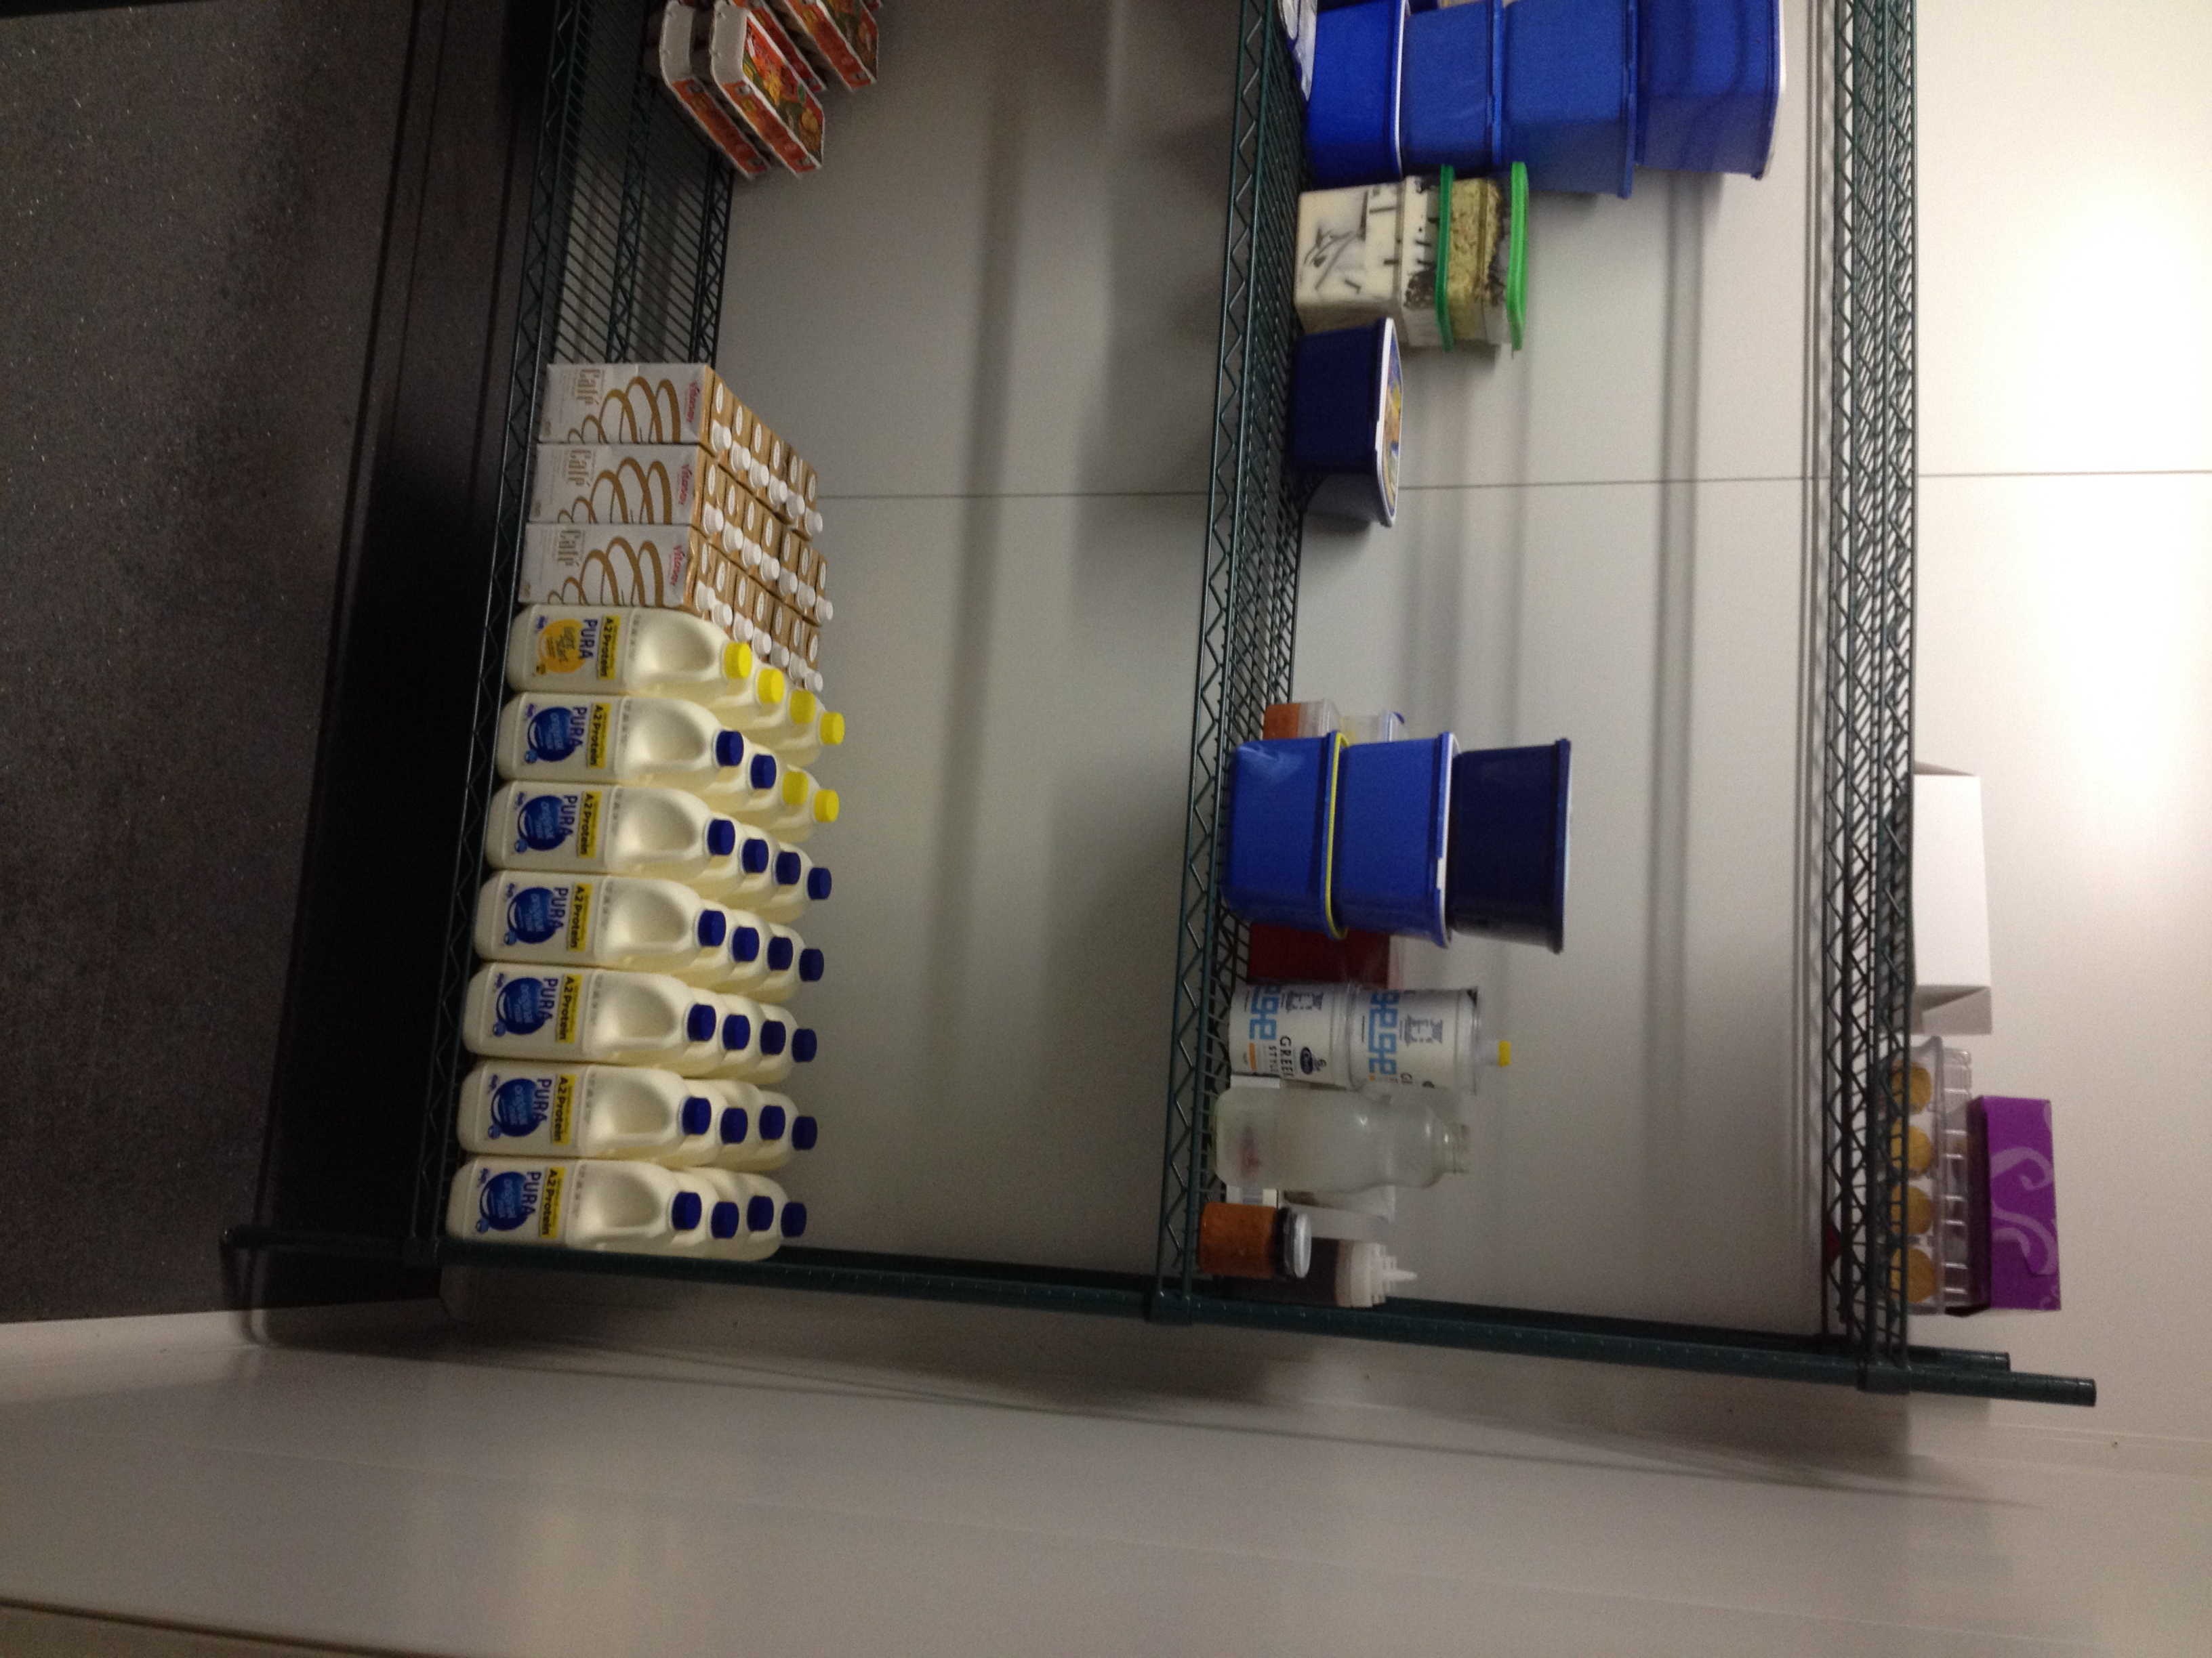 | An adequate and separate storage area should be provided for the storage of dry ingredients and other material.  Bulk items such as flour, rice and the like should be kept in impervious and airtight containers with tight fitting lids and be stored on shelves or on castors in storage areas.  Shelves are equipment and need to meet the General Requirements for equipment, fittings and fixtures including allowing 150mm above the floor.

3.1.3 Cooling and Refrigerated Storage and Display
When potentially hazardous food is to be processed and stored or displayed there must be adequate equipment to cool food rapidly and hold food under temperature control. Temperature control requirements that must be complied with are found in Standard 3.2.2.
Cool rooms and freezers must meet all the general requirements for floors, wall and ceilings, fixtures, fittings and equipment, wastewater disposal and lighting. In addition cold storage rooms should:
- Be equipped with an accurate thermometer.
- Have racks that allow the circulation of cold air.
- Have any motors located outside.

3.1.4 Utensils Storage
Storage areas need to be provided where all cleaned utensils and equipment are protected from contamination. Utensils or equipment should not have to be stored on the floor.

3.1.5 Food Display
Premises that will be displaying food must provide displays that protect food from the likelihood of contamination by customers by fitting displays with suitable barriers or displaying food in tamper resistant equipment or covered containers. | 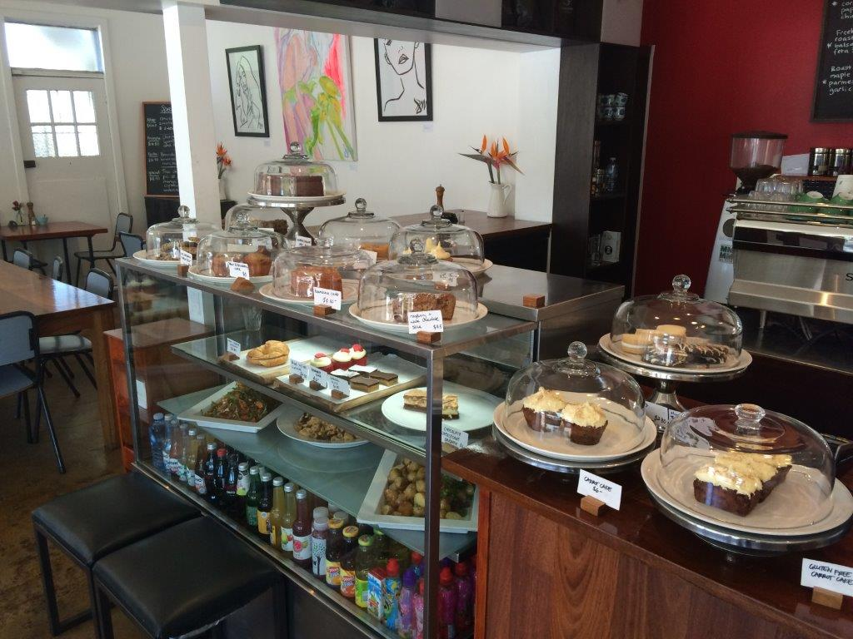
3.1.6 “Self-Serve” Food Displays.
Where displays of food are self serve, separate utensils for each food type must be provided that allow customers to obtain ready to eat food without using their hands or the food must be dispensed in a way that prevents contamination of other food in the display. The utensils must be capable of being stored so that their handles do not contaminate food or the utensils cannot become contaminated, eg chained to the display to prevent being dropped on the floor.
Self serve food displays will require constant supervision.

3.1.7 Cleaning and Sanitising Facilities
Food premises must have adequate and appropriate facilities for the effective cleaning and sanitising of the premise, appliances, equipment and fittings.
It is recommended that food premises have dishwashing machines because manual cleaning and sanitising of equipment using hot water can be difficult. The temperature that the water needs to get to (at least 77ºC for at least 30 seconds) is usually beyond the capabilities of most hot water services and the sink would need to have a heating element to keep the water in the sink above this temperature. It also raises occupation health and safety issues of burns and scalds from the hot water. | 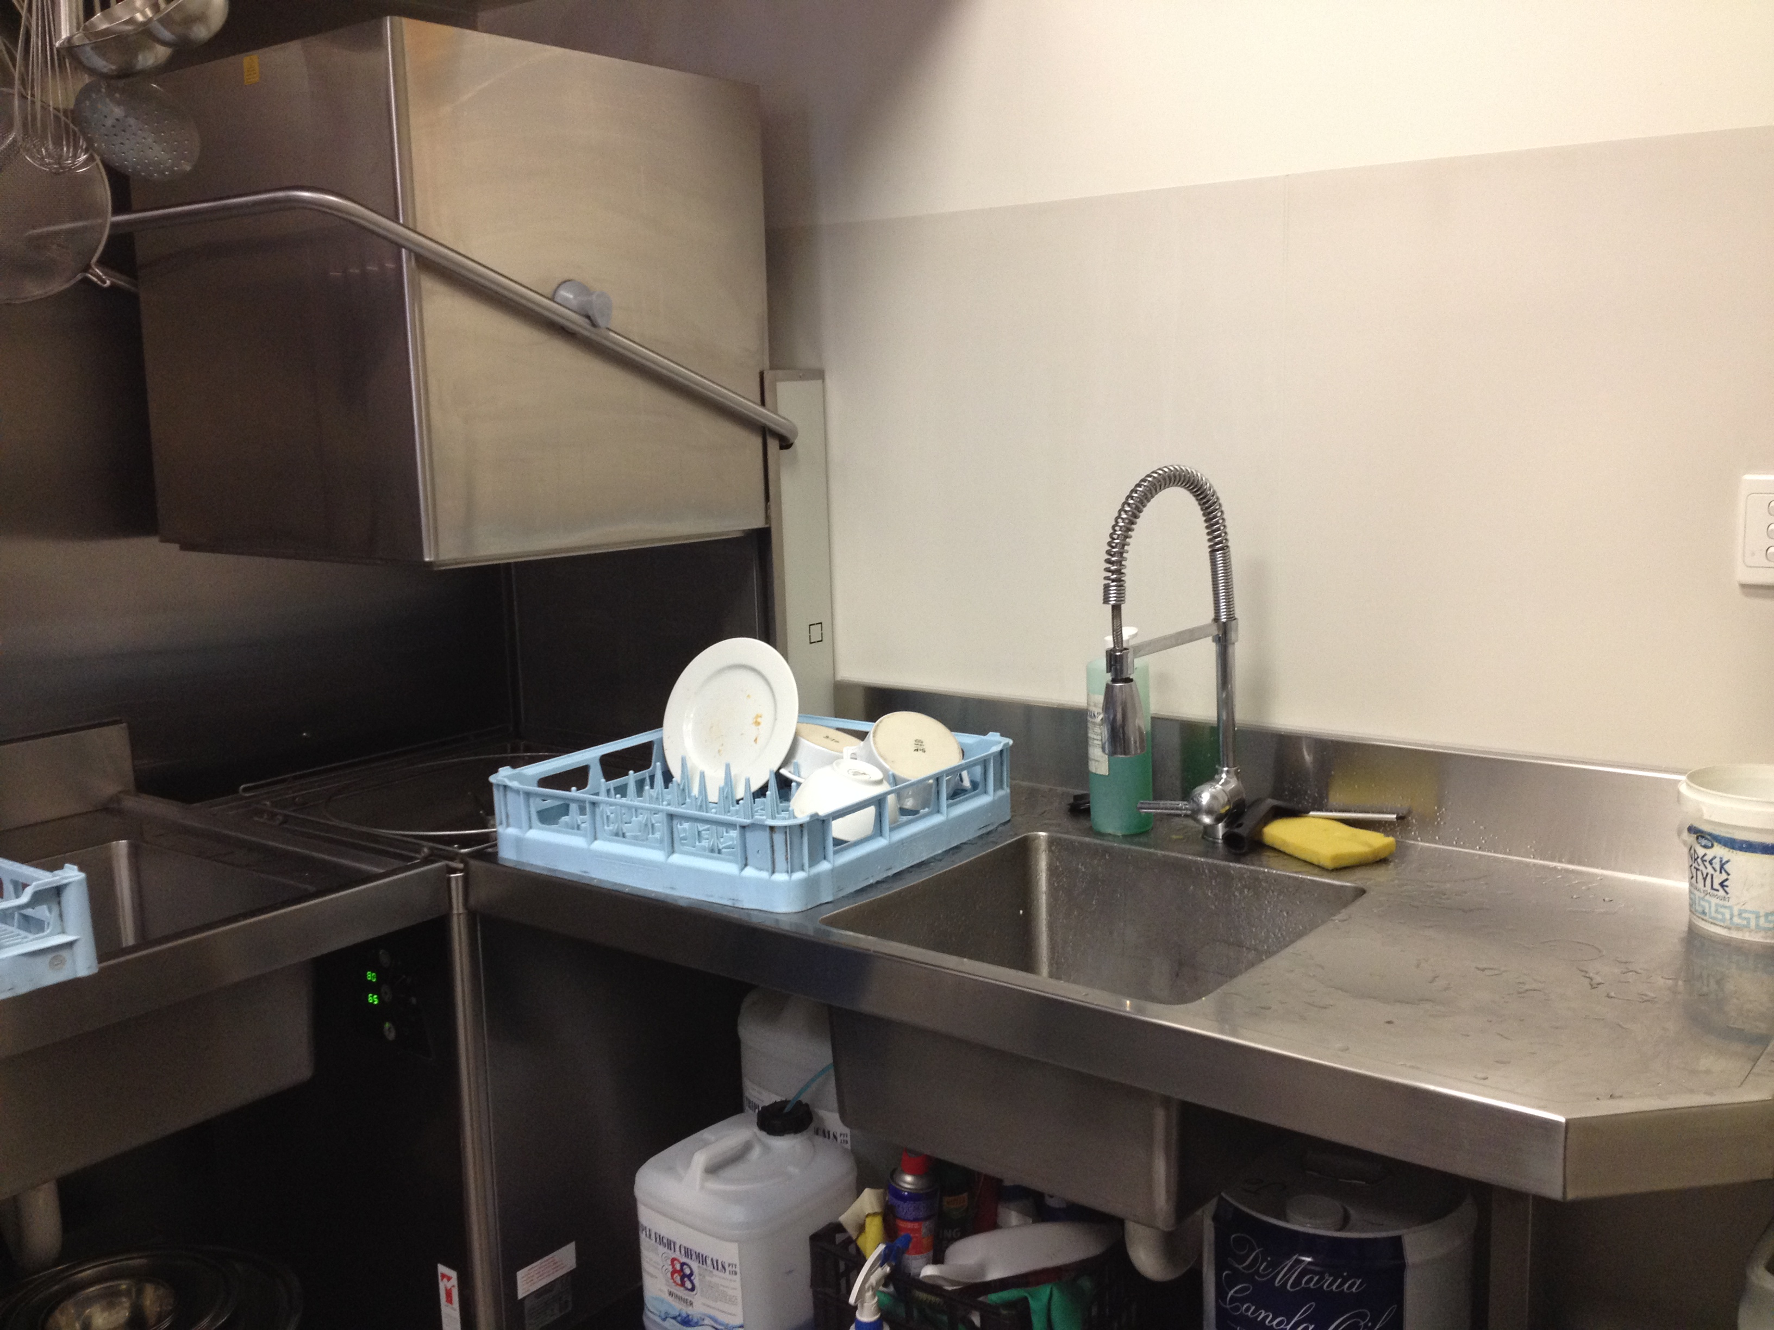
Dishwashing machines carry out both cleaning and sanitising in most situations.
3.1.8 Manual Cleaning and Sanitising Facilities
When sinks are to be used for manual washing at least one double bowl sink is required that:
- Is connected to an adequate supply of hot (70ºC) and cold water
- Has a drainer on at least one side.
- Is big enough to handle the largest pieces of equipment that will be washed.
- It still may be necessary for the premises use chemical sanitising even with this minimum facility.
3.1.9 Draining and Drying Racks
Where manual washing is used, drying racks for air-drying of cleaned utensils and appliances should be provided. Storage and draining racks are food contact surfaces and must meet the requirements for food contact surfaces.

3.1.10 Food Preparation Sinks
Where raw foods need to be washed or soaked as part of a preparation process a separate sink used only for that purpose should be installed to reduce the risk of cross contamination.

3.1.11 Cleaning Troughs
Where floor wastes are not installed and the floor will require mopping, a cleaner’s sink connected to the waste water system and supplied with adequate hot and cold water should be installed or the facilities in the garbage storage area can be used.

3.2 Design, Construction and Location of Fixtures, Fittings and Equipment (Clause 12 (2))
3.2.1 General Requirements
Fixtures, fittings and equipment must be designed, constructed, located and installed so that:
- They will not contaminate food.
- They can be easily and effectively cleaned.
- All surfaces around them including floors, walls, ceiling and surfaces of other equipment can be easily cleaned.
- They do not provide harbourage for pests.
3.2.2 Construction
Equipment should have smooth surfaces with rounded corners and no open joints or other rough surfaces or joints that can trap dirt and grease. If necessary, equipment must capable of being taken apart for thorough cleaning. The material used must be suitable to be in contact with food.
3.2.3 Location and Installation
Equipment should be easy to move (on wheels if necessary) or be located so there is space of at least 150 mm between surfaces. Equipment that is placed on the floor and is not easy to move should be on legs at least 150mm high.
For example, the area and surfaces around cooking equipment usually get dirty and greasy very easily. If flexible gas connections and lockable wheels are installed the equipment can be moved away from walls and other equipment to allow cleaning of the adjoining surfaces. In this case cookers can be placed right next to each.
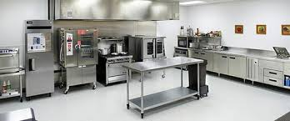

3.2.4 Food Contact Surfaces
In addition to the general requirements, the food contact surfaces of fixtures, fittings and equipment must be:
- unable to absorb grease, food particles and water (impervious)
- made of materials that will not contaminate food and
- able to withstand the intended sanitising process such as hot water above 70ºC or chemical sanitisers.
Suitable materials would be stainless steel, food grade plastic, laminated wood, although laminated wood can chip and crack overtime.
3.2.5 Connection of Specific Fixtures, Fittings and Equipment (Clause 13)
Fixtures fittings and equipment that use water for food handling and other activities and are designed to be connected to a water supply, for example, wash up sinks, must be connected to an adequate supply of water.
Fixtures, fittings and equipment that are designed to be connected to a sewerage and waste water system such as some cappuccino machines and refrigeration units in cool rooms must be connected to the sewerage and waste water system. This will reduce the risk of contamination of food and surfaces and aid with cleaning.
Automatic equipment that uses hot water to sanitise equipment must be designed so that they only carry out sanitising when the water is at a temperature that will sanitise. Businesses should contact the manufacturer of machines they intend to use for sanitising, if they need to establish that the machine’s time and temperature cycles will be adequate to sanitise.

3.3 Hand Washing Facilities (Clause 14)
Food premises must have hand-washing facilities that are easily accessible for food handlers to use and are only used for hand washing. They must be located:
- within areas where food handlers work, if their hands are likely to be a source of contamination of food and
- next to any food handlers toilets or toilet cubicles if there are toilets on the premises (see 4.2).
If there is more than one area in the premises where hands can be a source of contamination it may be necessary to have hand-washing facilities in each area.
Hand washing facilities must be:  - Permanent fixtures (does not apply to temporary food premises);  - Connected to an adequate supply of warm running clean water (through a single mixing tap).  - Large enough so that both hands can fit easily inside the bowl (350mm long by 200mm wide at least).  - Provided with soap and disposable paper towel with dispenser or hot air driers.  Having “hand free” devices or “flick mixers” may reduce the risk of re-contaminating hands from dirty tap handles. | 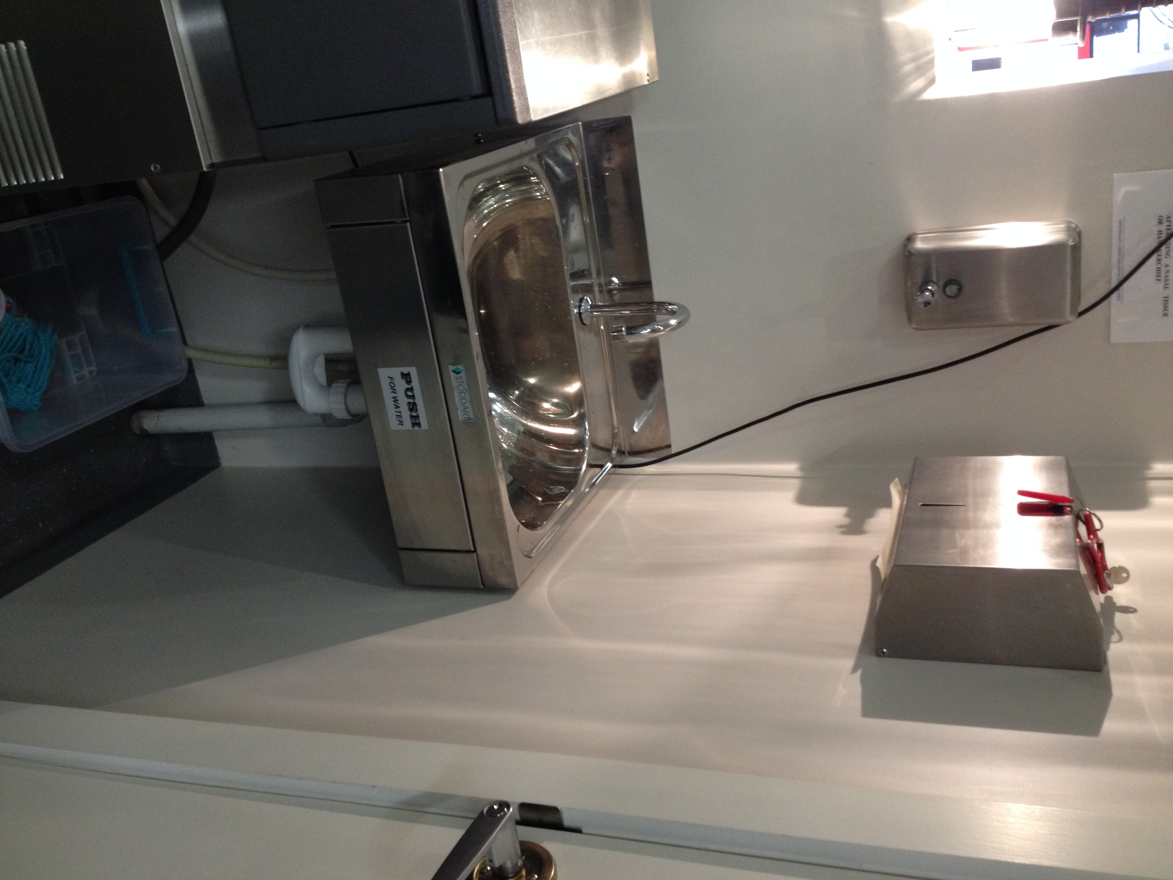
4. OTHER REQUIREMENTS

4.1 Storage of Chemicals, Clothing and Other Items (Clause 15)
The premises must have adequate facilities for storage of items that are likely to be a source of contamination.
This includes storage of clothing and personal belongings of staff, cleaning chemicals and detergents, pesticides and other chemicals, office type equipment such as paper clips and staples and dirty linen and laundry.  Such storage facilities should ideally be located away from food preparation areas. If this is not possible the storage should be provided in a cupboard, locker or other designated area. | 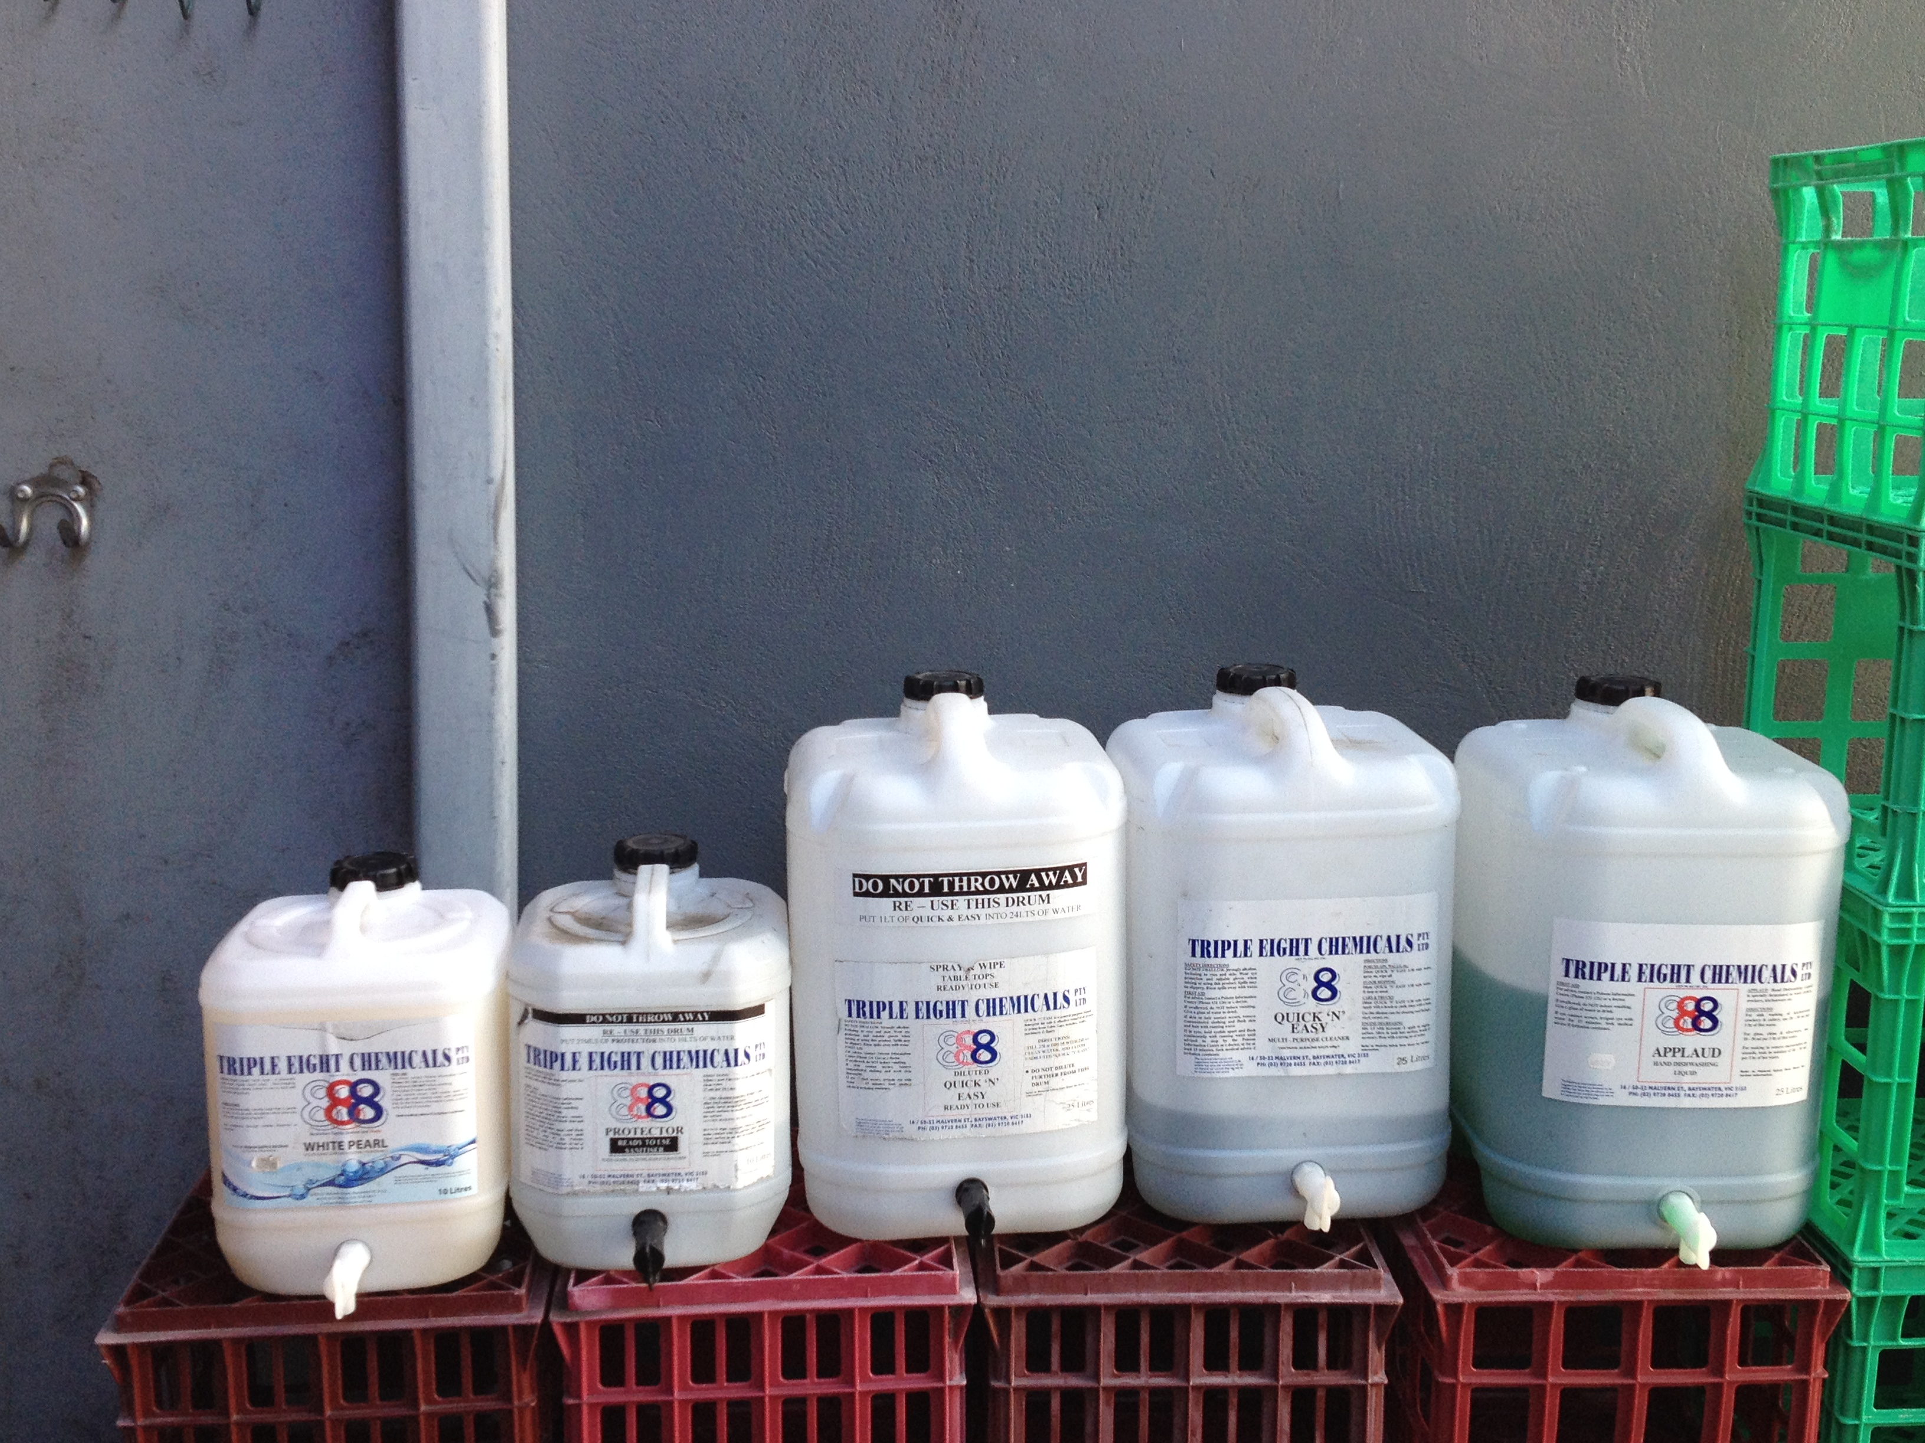

4.2 Toilet Facilities (Clause 16)

Premises must have toilet facilities for the use of food handlers that are available either on the premises or nearby.
To minimise the risk of contamination of food, toilets in a food premises must be located so that they do not open directly onto any room in which any food is handled or stored by providing an airlock, hallway or other room. All doors should be tight fitting and self-closing.
If toilets for customers are provided, the public should not have to go through food handling or storage areas to reach them as this increases the risk of food contamination.
The number of toilets that need to be provided for customers and staff is covered under the Building Code of Australia. Yarra Building Services can be contacted on 9205 5095 for information and advice.

4.3 Food Transport Vehicles (Clause 17)

Where a food premises will be transporting food, any vehicle used must be designed and constructed to protect the food being transported.
The parts of the vehicles used to transport food must be designed and constructed so that they are easy to be effectively cleaned. The driving section of the food transport vehicle should be effectively sealed off from the area where food is stored or food should be stored in sealed containers, for example, insulated coolers. The internal surfaces of the vehicle or food containers should be smooth and impervious to allow effective cleaning.
If potentially hazardous food is transported, the vehicle must have some way to keep the food under temperature control. This means that the vehicle may need to be provided with either a refrigeration system for cold food, through the use of ice bricks in insulated containers or a heating system for hot food.
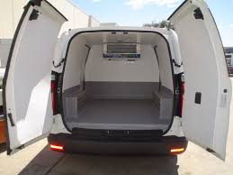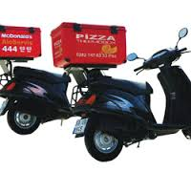

Appendix – Registration and Registration Inspection Checklist

Registration
All Class 1, 2 and 3 food premises must be registered under the Food Act 1984. An application for registration must be submitted to the Yarra City Council that provides all the relevant details. Registration will only be considered if the application is complete and correct, the required fees have been paid and the premises complies with all other requirements of the Food Act 1984 including all structural requirements relevant to the premises as detailed in these guidelines (see Registration Inspection below).
There are other requirements that need to be met such as Food Safety Programs and Food Safety Supervisors details which must be provided on the application to register the premises. Information on these is available from the Health Protection Unit.

Registration Inspection
To ensure the premises complies with Standard 3.2.3 Council’s authorised officer must conduct a Registration Rnspection. The checklist below is used by the officers during the inspection.
Exclusion of dust, fumes, smoke etc. | ✓
Adequate space for activities and equipment. | ✓
Exclusion of pests, no harbourage for pests | ✓
Effective food protection for open shop fronts/outside dining (if applicable). | ✓
Adequate water supply (hot and cold). | ✓
Adequate sewage and waste water disposal. | ✓
Adequate storage of garbage and other waste including protection of stormwater. | ✓
Adequate ventilation, including the exhaust system over cooking appliances working. | ✓
Adequate lighting and lights working. | ✓
Suitable flooring. | ✓
Suitable wall surfaces. | ✓
Suitable ceiling finishes. | ✓
Adequate cold food storage facilities. | ✓
Adequate dry food storage facilities. | ✓
Adequate utensil storage facilities. | ✓
Adequate food displays including self-serve displays (food protected). | ✓
Adequate cleaning and sanitising facilities including machine and manual washing. | ✓
Adequate food preparation sinks. | ✓
Adequate cleaner’s trough (if required). | ✓
Construction and materials of fittings, fixtures and appliances. | ✓
Location and installation of fittings, fixtures and equipment to allow easy cleaning. | ✓
Suitable food contact surfaces. | ✓
Adequate hand washing facilities in food preparation and staff toilet areas including soap and hand drying facilities. | ✓
Adequate facilities for storage of chemicals, clothing and other items. | ✓
Adequate toilets for food handlers. | ✓
Adequate methods to transport food (if applicable). | ✓
All building and construction material has been removed from premises. | ✓
Premises has been thoroughly cleaned. | ✓
Food contact surfaces have been effectively cleaned and sanitised. | ✓
Refrigeration is operating at correct temperatures. | ✓
Hot water to hot water taps is at the correct temperature. | ✓
All other equipment is operating properly. | ✓
Thermometer is on site and has been calibrated. | ✓
Hand wash basin/s are supplied with warm water, soap, hand drying facility. | ✓

FURTHER INFORMATION
If you have any questions about these guidelines contact the Health Protection Unit on 9205 5555 or e-mail info@yarracity.vic.gov.au.

