Applying online user guide
  - Construction Management Plans (CMP)

Important information

Please read, this will help when using the online portal.

First time customer

- If you don’t have an online account, please call Construction Management Support Unit. We will request details from you to set you up with an online account.
- One account will be created with the company email address (not individual). This account will be used for submitting the Construction Management Plan and any other permit applications required during the build.
- During your transaction, you will have the opportunity to enter a delivery email address for each application. The delivery email address entered will receive any email correspondence relating to that application. You have the option to enter a company or individual email address.
- Keep record of your user name, email address & password. One account can be used by multiple people within the same company.
- To log in, you will need your User Name & Password.
- If you forget your Password, you will need your email address.

Repeat customer

- Before starting your transaction, accept the terms and conditions page and then login.
- The user name would have been provided to you when setting up the account.
- If you forget the user name, please do not create a new account with a different email address. Contact us so we can give you the details.
- If you forget your password, change now before proceeding.
- If you receive any errors after logging in, try logging out and logging back in.
- If you are still having issues, contact us on 9205 5555 and we will assist.

This user guide will help with applying for applications online or if you have forgotten your password.

How do I apply

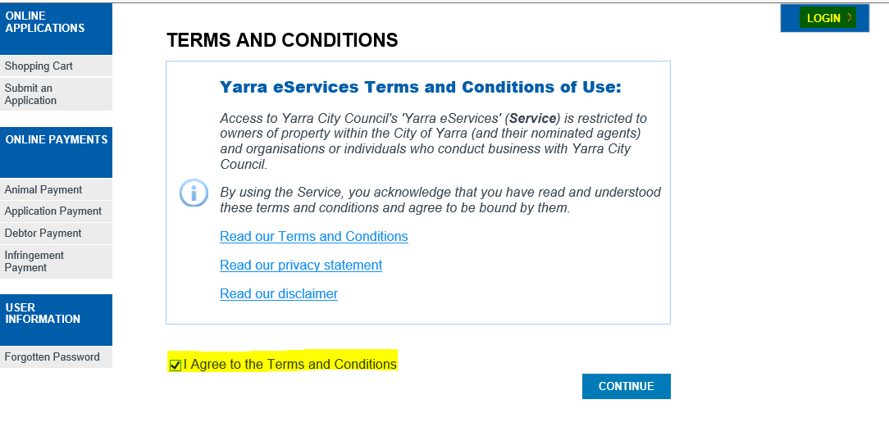 | Click here to submit the application.  Read through Council’s Terms and Conditions.  Tick Agree to the Terms and Conditions.  Click on Continue.
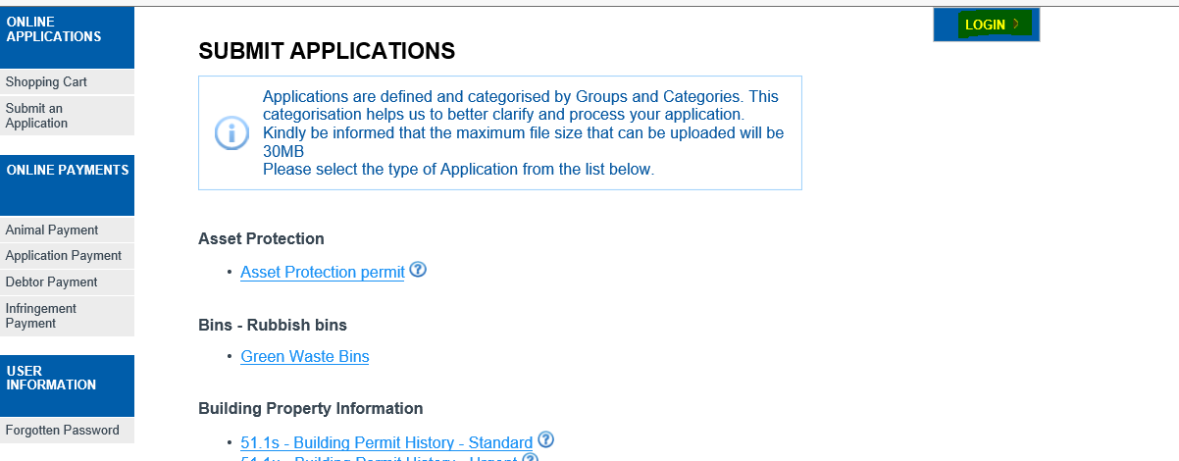 | Login before proceeding.  Select required application type under the heading.  Click to view further information
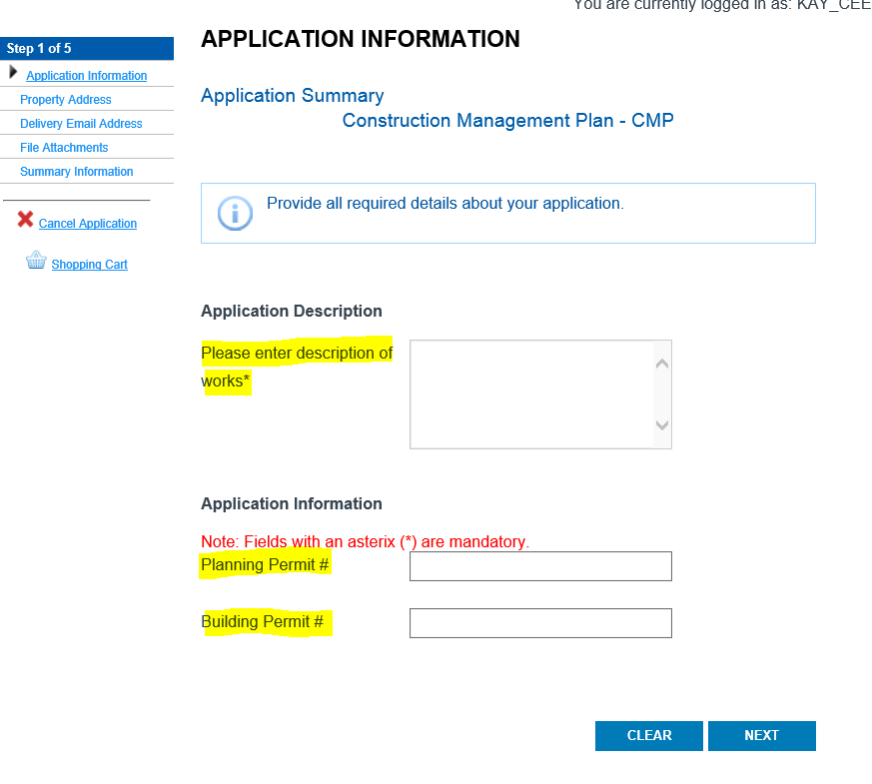 | Enter  Description of Works  Planning Permit Number  Building Permit Number  Click Next
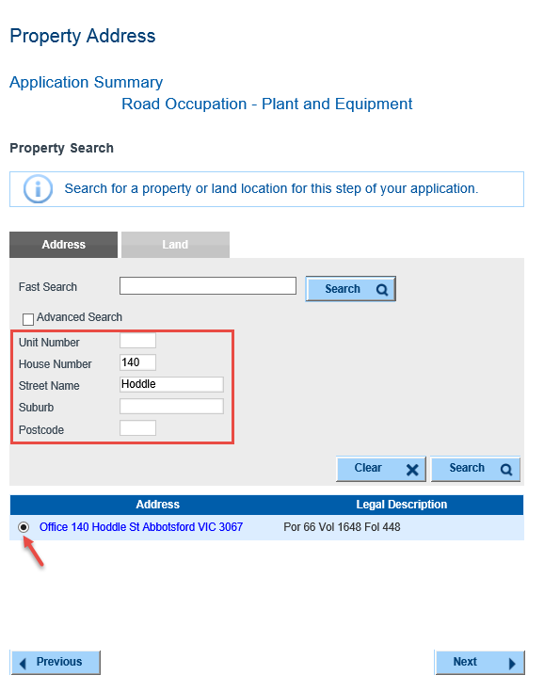 | Enter Property Address  Click on Search.  Select required Property Address (where multiply addresses are displayed).  Click Next
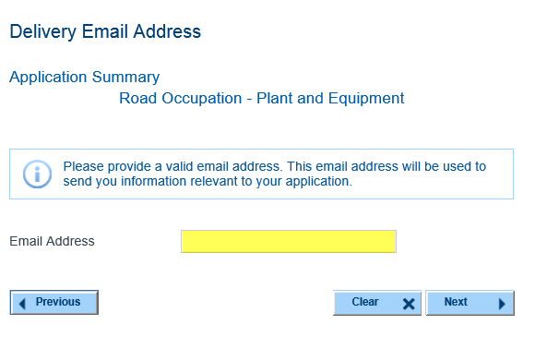 | Enter Delivery Email Address.  This email address will be used to send you information regarding your application.  For companies, the person submitting the application and who wants the email correspondence can enter their individual address here.
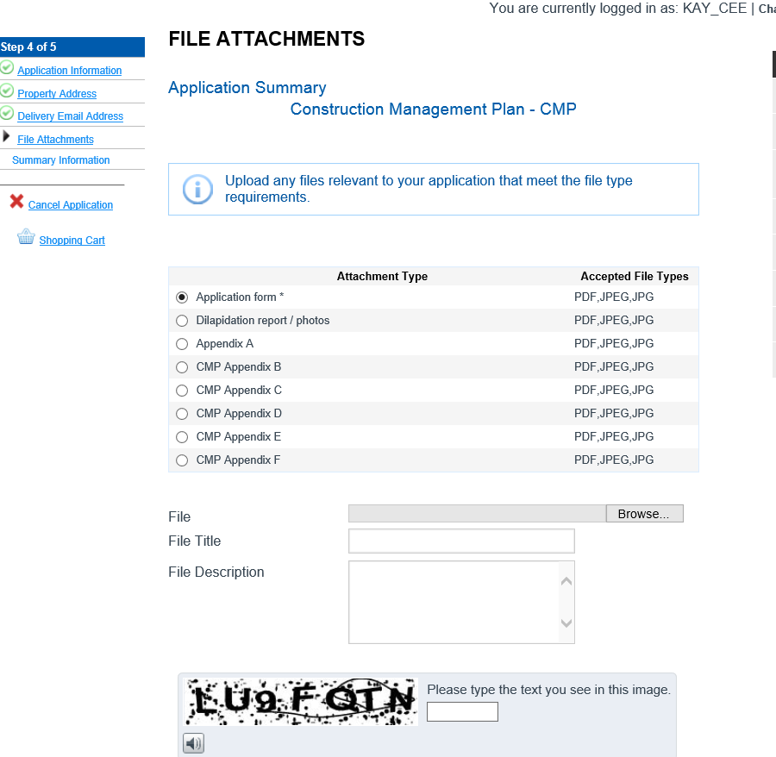 | Click on required Attachment Type.  Maximum file size – 30MB  Accepted file types – PDF, JPEG & JPG  Click Browse and locate your attachment.  Enter File Title and File Description if required.  Enter Image Text.  Click Upload.  Repeat steps to upload all required attachments as outlined on the application form.  The application form is marked * and mandatory for all applications. You have the option to upload all required documentation in one file under application form or attached documents separately. You must submit all required documentation as outlined on the application form.  Click on Help items if you require further information regarding permit requirements.
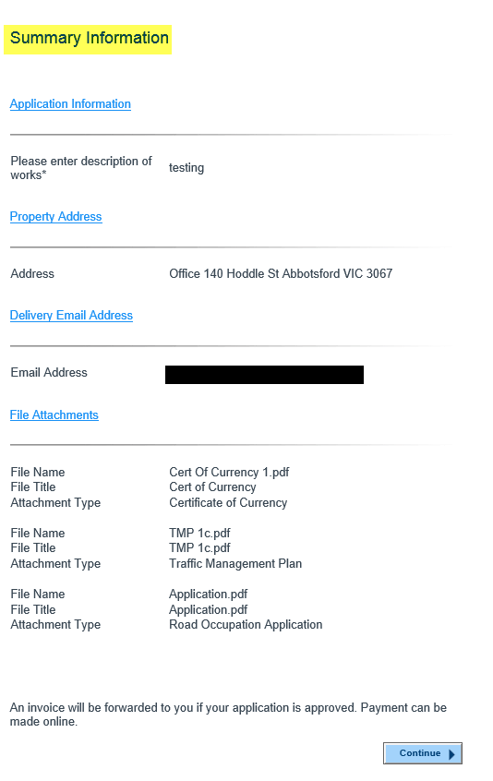 | Summary of application information.  Click Continue
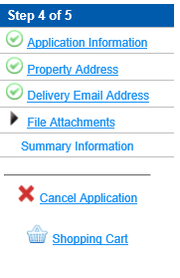 | If you need to amend any part of your application, click on the relevant Step to go back.
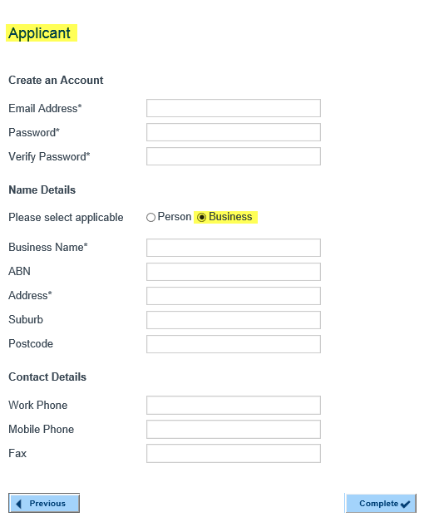 | You should be logged in and the details below populated.  Click Complete.
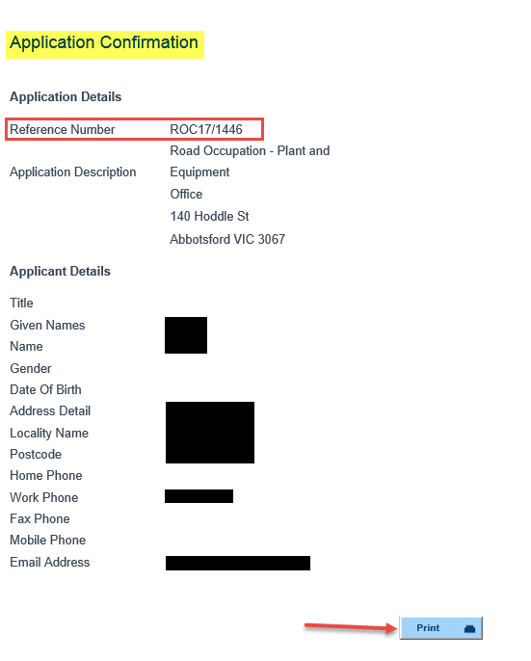 | Confirmation of your Application with your Application Reference Number.  Click Print if you wish to print a copy of this information.  An acknowledgement email will also be sent to you with this information.
Logout when you have completed your application(s).
This located on the top right hand side of the page.

Forgotten password

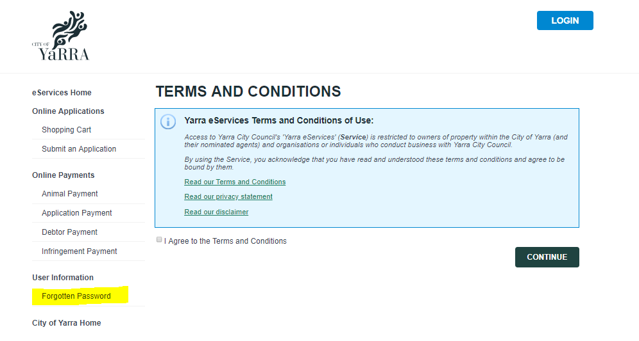 | Click on Forgotten Password
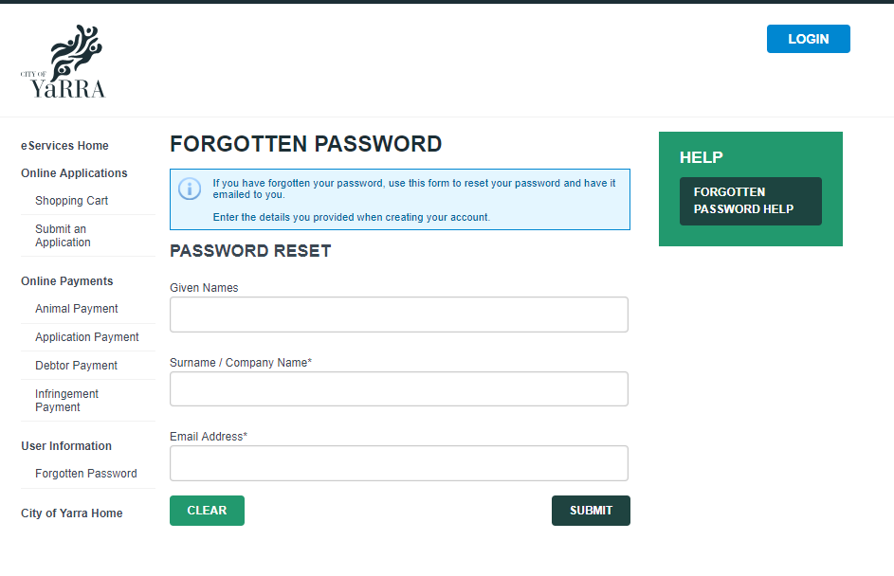 | Enter details used to set up the account:  Surname/ Company name  Email Address  Click Submit  Please contact Council if you are not sure of your account details.
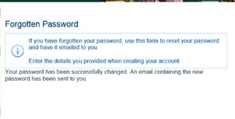 | Password is now reset  An email with a temporary new password will be sent to the email address supplied with your initial registration.
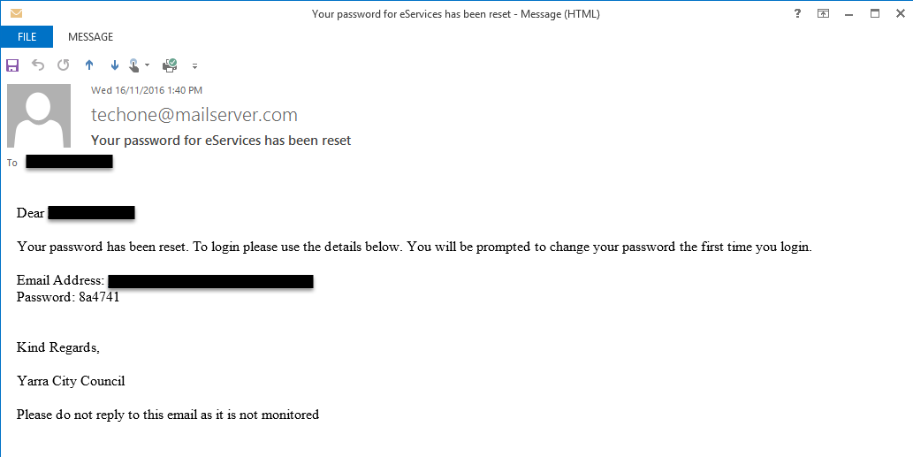 | Email with new password.

