22.02 DEVELOPMENT GUIDELINES FOR sites subject to the HERITAGE overlay

xx/xx/xxxx C231

This policy applies to all land within a Heritage Overlay.

22.02-1 Policy Basis

30/09/2010

C85

The MSS highlights the importance of heritage to the identity and character of the municipality and one of its objectives is to protect and enhance the City’s heritage places.

This policy provides guidance for the protection and enhancement of the City’s identified places of cultural and natural heritage significance.

22.02-2 Definitions of Words used in this Policy

30/09/2010

C85

* Adaptation: modifying a place to suit the existing use or a proposed use.
* Architectural integrity: the quality of closely reflecting the architecture of the period in which a building was created.
* Conservation: the process of looking after a place so as to retain its cultural significance.
* Cultural significance: aesthetic, historic, scientific, social or spiritual value for past, present or future generations.
* Fabric: all the physical material of the place including components and fixtures, and can include building interiors.
* Heritage place: anything subject to the Heritage Overlay and can include a site, area, land, landscape, tree, building or other work, or group of buildings of heritage significance, and may include components or spaces. When used in the context of a building graded individually significant, the heritage place is initially the individually significant building and then the broader heritage area. When used in the context of a contributory building, the heritage place is the broader heritage area.
* Maintenance: the continuous protective care of the fabric and setting of a place. It is distinguished from repair which involves restoration and reconstruction.
* Preservation: maintaining the fabric of a place in its existing state and retarding deterioration.
* Reconstruction: returning a place to a known earlier state and is distinguished from restoration by the introduction of new material into the fabric.
* Restoration: returning the existing fabric of a place to a known earlier state and is distinguished from reconstruction by no introduction of new material into the fabric (note a permit is only required for works, repairs and routine maintenance which change the appearance of a heritage place or which are not undertaken to the same details, specifications and materials).

22.02-3 Levels of Significance

19/10/2017

C235

Every building of cultural significance has been assessed and graded according to its heritage contribution. The levels of significance used are:

* Individually significant: The place is a heritage place in its own right. Within a Heritage Overlay applying to an area each individually significant place is also Contributory.
* Contributory: The place is a contributory element within a larger heritage place. A contributory element could include a building, building groups and works, as well as building or landscape parts such as chimneys, verandahs, wall openings, rooflines and paving.
* Not contributory: The place is not individually significant and not contributory within the heritage place.

The level of significance of every building is identified in the incorporated document, *City of Yarra Review of Heritage Overlay Areas 2007 Appendix 8* (as updated from time to time)*.* Details of methodology used to determine levels of significance can be found in *City of Yarra Review of Heritage Overlay Areas 2007 (Graeme Butler and Associates)*, *City of Yarra Heritage Gaps Review Two 2013, City of Yarra Hertiage Gaps Study July, 2014 – Smith Street South (Anthemion),* and *Heritage Gap Study: Review of Central Richmond, Stage 2 Final Report, November 2014.*

22.02-4 Objectives

30/09/2010

C85

To conserve Yarra’s natural and cultural heritage.

To conserve the historic fabric and maintain the integrity of places of cultural heritage significance.

To retain significant view lines to, and vistas of, heritage places.

To preserve the scale and pattern of streetscapes in heritage places.

To encourage the preservation, maintenance, restoration and where appropriate, reconstruction of heritage places.

To ensure the adaptation of heritage places is consistent with the principles of good conservation practice.

To ensure that additions and new works to a heritage place respect the significance of the place.

To encourage the retention of ‘individually significant’ and ‘contributory’ heritage places.

To protect archaeological sites of cultural heritage significance.

22.02-5 Policy

19/10/2017

C235

It is policy to:

22.02-5.1 Demolition

19/10/2017

C235

Full Demolition or Removal of a Building

Generally encourage the retention of a building in a heritage place, unless

* The building is identified as being not contributory.
* The building is identified as a contributory building, and
* new evidence has become available to demonstrate that the building does not possess the level of heritage significance attributed to it in the incorporated document*, City of Yarra Review of Heritage Areas 2007 Appendix 8* (as updated from time to time)and
* the building does not form part of a group of similar buildings.

Note: The poor condition of a heritage place should not, in itself, be a reason for permitting demolition.

Encourage the retention of original street furniture and bluestone road or laneway materials and details (where relevant).

An application for demolition is to be accompanied by an application for new development.

Removal of Part of a Heritage Place or Contributory Elements

Encourage the removal of inappropriate alterations, additions and works that detract from the cultural significance of the place.

Generally discourage the demolition of part of an individually significant or contributory building or removal of contributory elements unless:

* That part of the heritage place has been changed beyond recognition of its original or subsequent contributory character(s).
* For a contributory building:
* that part is not visible from the street frontage (other than a laneway), abutting park or public open space, and the main building form including roof form is maintained; or
* the removal of the part would not adversely affect the contribution of the building to the heritage place.
* For individually significant building or works, it can be demonstrated that the removal of part of the building or works does not negatively affect the significance of the place.

22.02-5.2 Original Location

30/09/2010

C85

Encourage the retention of a heritage place or a contributory element to a heritage place in its original location unless:

* The location is not an important component of the cultural significance of the heritage place.
* It can be shown that the relocation is the only reasonable means of ensuring the survival of the heritage place.

22.02-5.3 Reconstruction and Restoration

30/09/2010

C85

Encourage restoration of a heritage place or contributory element if evidence exists to support its accuracy.

Encourage the reconstruction of a building or works which previously existed in a heritage place if:

* The reconstruction will enhance the heritage significance of the heritage place
* Evidence exists to support the accuracy of the reconstruction.

Encourage the reconstruction of original or contributory elements where they have been removed. These elements include, but are not limited to, chimneys, fences, verandahs, roofs and roof elements, wall openings and fitting (including windows and doors), shopfronts and other architectural details and features.

22.02-5.4 Painting and Surface Treatments

30/09/2010

C85

Encourage the removal of paint from originally unpainted masonry surfaces.

Encourage the retention of historic painted signs.

Discourage the sand blasting of render, masonry or timber surfaces; and the painting of unpainted surfaces.

Encourage paint colours to be consistent with the period of the heritage place.

22.02-5.5 Culturally Significant Trees

30/09/2010

C85

Encourage the retention of culturally significant trees in a heritage place unless:

* The trees are to be removed as part of a maintenance program to manage loss of trees due to deterioration caused by old age or disease.
* The trees are causing structural damage to an existing structure and remedial measures (such as root barriers and pruning) cannot be implemented.

Ensure additions and new works respect culturally significant trees (and where possible, significant garden layouts) by siting proposed new development at a distance that ensures the ongoing health of the tree.

22.02-5.6 Subdivision

30/09/2010

C85

Support the subdivision of sites which do not detract from the heritage value of the place or contributory element.

Where appropriate, use a building envelope plan to protect the heritage values of the place. The building envelope plans should:

* Reflect the original rhythm of the streetscape.
* Allow sufficient space surrounding the heritage place or contributory element to a heritage place to retain its significance or contribution.

22.02-5.7 New Development, Alterations or Additions

30/09/2010

C85

22.02-5.7.1 General

30/09/2010

C85

Encourage the design of new development and alterations and additions to a heritage place or a contributory element to a heritage place to:

* Respect the pattern, rhythm, orientation to the street, spatial characteristics, fenestration, roof form, materials and heritage character of the surrounding historic streetscape.
* Be articulated and massed to correspond with the prevailing building form of the heritage place or contributory elements to the heritage place.
* Be visually recessive and not dominate the heritage place.
* Be distinguishable from the original historic fabric.
* Not remove, cover, damage or change original historic fabric.
* Not obscure views of principle façades.
* Consider the architectural integrity and context of the heritage place or contributory element.

Encourage setbacks from the principal street frontage to be similar to those of adjoining contributory buildings; where there are differing adjoining setbacks, the greater setback will apply.

Encourage similar façade heights to the adjoining contributory elements in the street. Where there are differing façade heights, the design should adopt the lesser height.

Minimise the visibility of new additions by:

* Locating ground level additions and any higher elements towards the rear of the site.
* Encouraging ground level additions to contributory buildings to be sited within the ‘envelope’ created by projected sight lines (see Figure 1)
* Encouraging upper level additions to heritage places to be sited within the ‘envelope’ created by projected sight lines (for Contributory buildings refer to Figure 2 and for Individually significant buildings refer to Figure 3).
* Encouraging additions to individually significant places to, as far as possible, be concealed by existing heritage fabric when viewed from the front street and to read as secondary elements when viewed from any other adjoining street.

Discourage elements which detract from the heritage fabric or are not contemporary with the era of the building such as unroofed or open upper level decks or balconies, reflective glass, glass balustrades and pedestrian entrance canopies.

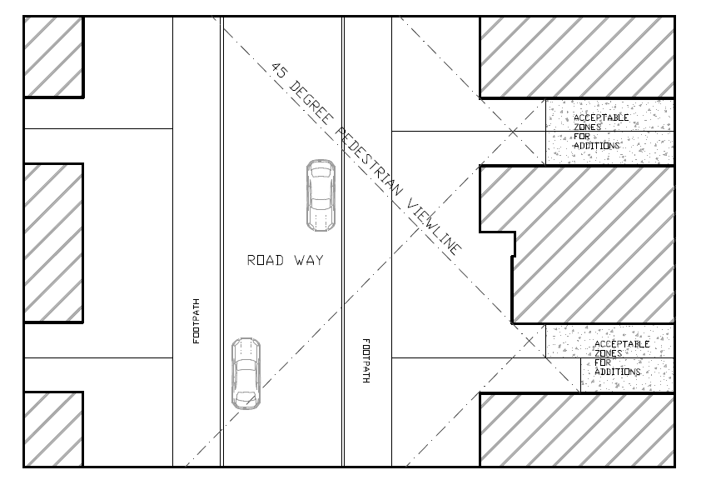

**Figure 1** acceptable areas for ground level additions are sited within the area created by drawing a 45 degree view line from the opposite footpath through the front corner of the subject building and the corners of adjacent buildings.

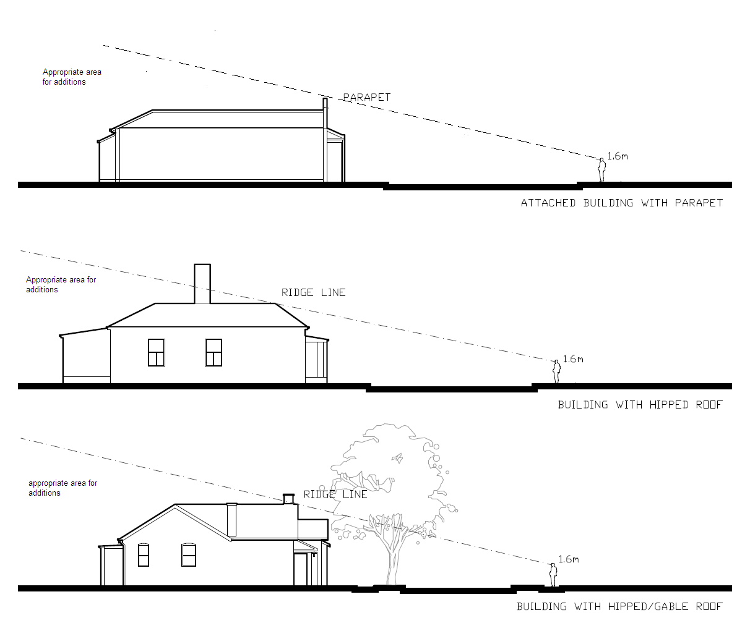

**Figure 2 –** appropriate areas for upper level additions to contributory buildings are sited within the ‘envelope’ created by projecting a sight line from 1.6 metres above ground level (eye level of average adult person) from the footpath on the opposite side of the street through the top of the front parapet or the ridge line of the principal roof form.



**Figure 3 –** appropriate areas for upper level additions to individually significant buildings are sited within the ‘envelope’ created by projecting a sight line from 1.6 metres above ground level (eye level of average adult person) from the footpath on the opposite side of the street through the top of the front parapet or the gutter line of the principal roof form.

22.02-5.7.2 Specific Requirements (where there is a conflict or inconsistency between the general and specific requirements, the specific requirements prevail)

30/09/2010

C85

Corner Sites and Sites with Dual Frontages

Encourage new building and additions on a site with frontages to two streets, being either a corner site or a site with dual street frontages, to respect the built form and character of the heritage place and adjoining or adjacent contributory elements to the heritage place.

Encourage new buildings on corner sites to reflect the setbacks of buildings that occupy other corners of the intersection.

Residential Upper Storey Additions

Encourage new upper storey additions to residential heritage places or contributory elements to heritage places to:

* Preserve the existing roof line, chimney(s) and contributory architectural features that are essential components of the architectural character of the heritage place or contributory elements to the heritage place.
* Respect the scale and form of the heritage place or contributory elements in the heritage place by stepping down in height and setting back from the lower built forms.

Sightlines should be provided to indicate the ‘envelope’ from the street of proposed upper storey additions (refer to the sightline diagrams in 22.02-5.7.1).

Industrial, Commercial and Retail Heritage Place or Contributory Elements

Encourage new upper level additions and works to:

* Respect the scale and form of the existing heritage place or contributory elements to the heritage place by being set back from the lower built form elements. Each higher element should be set further back from lower heritage built forms.
* Incorporate treatments which make them less apparent.

Carports, Car Spaces, Garages, and Outbuildings

Encourage carports, car spaces, garages and outbuildings to be set back behind the front building line (excluding verandahs, porches, bay windows or similar projecting features) of the heritage place or contributory element or to be reasonably obscured. New works should be sited within the ‘envelope’ shown in Figure 1 of 22.02-5.7.1.

Discourage:

* new vehicle crossovers in streets with few or no crossovers
* high fencing, doors and boundary treatments associated with car parking that are unrelated to the historic character of the area
* new vehicle crossovers in excess of 3 metres wide in residential streets.

Front Fences and Gates

Encourage front fences and gates to be designed to

* allow views to heritage places or contributory elements from surrounding streets
* be a maximum of 1.2 metres high if solid or 1.5 metres high if more than 50% transparent (excluding fence posts)
* be consistent with the architectural period of the heritage place or contributory element to the heritage place.

Ancillaries and Services

Encourage ancillaries or services such as satellite dishes, shade canopies and sails, access ladders, air conditioning plants, wall and roof top mounted lighting, roof top gardens and their associated planting, water meters, and as far as practical aerials, to contributory or significant buildings, to be concealed when viewed from street frontage.

Where there is no reasonable alternative location, ancillaries and services which will reduce green house gas emissions or reduce water consumption, such as solar panels or water storage tanks, or provide universal access (such as wheel chair ramps), may be visible but should be sensitively designed.

Encourage ancillaries or services in new development to be concealed or incorporated into the design of the building.

Encourage ancillaries or services to be installed in a manner whereby they can be removed without damaging heritage fabric.

22.02-6 Archaeological Sites

30/09/2010

C85

Encourage applicants to consult with Heritage Victoria where any proposed buildings or works may affect archaeological relics to facilitate compliance with Part 6 of the *Heritage Act 1995* (Protection of Archaeological Places).

22.02-7 Decision Guidelines

30/09/2010

C85

Before deciding on an application the responsible authority will consider:

* Whether there should be an archival recording of the original building or fabric on the site.
* The heritage significance of the place or element as cited in the relevant Statement of Significance or Building Citation.

22.02-8 References

xx/xx/xxxx C231

Yarra High Streets: Statements of Significance GJM Heritage October 2017 (updated November 2017)

Heritage Citation: 112-124 Trenerry Crescent, Abbotsfod. GJM Heritage, July 2016.

Heritage Citation: 20-60 Trenerry Crescent, Abbotsfod. GJM Heritage, July 2016.

Heritage Gap Study: Review of 17 Precincts Stage 2 Report August 2014, Revised 16 October 2016 (Context Pty Ltd)

Heritage Review of Predefined Areas In Abbotsford & Collingwood Stage 2 Report July 2015 (Context Pty Ltd).

Heritage Gap Study: Review of Central Richmond, Stage 2 Final Report, November 2014 (Context Pty Ltd).

City of Yarra Heritage Gaps Study July 2014 – Smith Street South (Anthemion Consultancies)

City of Yarra Heritage Gaps Review One 2013 [Appendix A and B includes Statements of Significance] Incorporated Plan under the provisions of clause 43.01 Heritage Overlay - methodology report, July 2014

City of Yarra Heritage Gaps Review Two 2013

City of Yarra Heritage Gaps Study October 2012 – 233-251 Victoria Street, Abbotsford (Anthemion Consultancies)

City of Yarra Review of Heritage Overlay Areas 2007 (Graeme Butler and Associates) [Appendix 7 includes Statements of Significance]

Yarra Heritage Database 2007 including photos

“City of Yarra Heritage Review”, Allom Lovell and Associates, 1998.

“City of Yarra Heritage Review”, Building Citations Volume 2 Part I and II, Allom Lovell and Associates

“Protecting Archaeological Sites in Victoria”, Heritage Victoria, 1998.

The Australian ICOMOS Charter for the Conservation of Places of Cultural Significance

“Fitzroy Urban Conservation Study Review”, Allom Lovell and Associates, 1992.

“Collingwood Conservation Study”, Andrew Ward and Associates, 1989.

“Richmond Conservation Study”, J and T O’Connor and Coleman and Wright Architects, 1985.

“Carlton, North Carlton and Princes Hill Conservation Study”, Nigel Lewis and Associates, 1984.

“City of Northcote Urban Conservation Study”, Graeme Butler Architect, 1982.

“South Fitzroy Conservation Study”, Jacob Lewis Vines Architects, 1979.

“North Fitzroy Conservation Study”, Jacob Lewis Vines Architects, 1978.