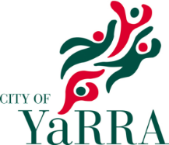
Yarra Environment Advisory Committee
Expression of Interest
Due: Monday 22nd January

I am interested in being a member of the Yarra Environment Advisory Committee.

1. CONTACT INFORMATION
Council may need to contact you to discuss your EOI in more detail.

Name Click here to enter text. Phone Click here to enter text.
Email Click here to enter text. Address Click here to enter text.
Suburb Click here to enter text. Postcode Click here to enter text.

2. GENERAL INFORMATION

2a. Tell us a little bit about yourself, including your environmental interests, skills, knowledge and experience which you believe you could bring to the Committee. Click here to enter text.

2b. Please outline any relevant skills and experience you have in working collaboratively in a group at a strategic level. Click here to enter text.

2c. What key outcomes do you hope the Committee will focus on? Click here to enter text.

2d. Are you a member of a local community/environment group? (Yes/No) Click here to enter text.
If yes, what is the name of the group? Click here to enter text.

2e. I confirm that I am not a member of another Yarra City Council Community Advisory Committee. (Yes/No) Click here to enter text.

2f. What is your connection to the City of Yarra? Click here to enter text.

Thank You.

Please email your completed application to Courtney.deans@yarracity.vic.gov.au before 5pm, Monday 22nd January.

